**Development of Car Service Management System for KODEEO**

**Mehedi Hassan**

ID: 18103227

A Practicum Report submitted in partial fulfillment of the requirements for the award of Bachelor of Computer Science and Engineering



**Department of Computer Science and Engineering**

College of Engineering and Technology

IUBAT – International University of Business Agriculture and Technology

Summer 2023

**Development of Car Service Management System For KODEEO**

**Mehedi Hassan**

A Practicum Report submitted in partial fulfillment of the requirements for the award of Bachelor of Computer Science and Engineering

The Practicum has been examined and approved by

______________________________

**Prof. Dr. Utpal Kanti Das**

Professor & Chair

Department of Computer Science and Engineering

IUBAT – International University of Business Agriculture and Technology

______________________________

**Dr. Hasibur Rashid Chayon**

Associate Professor & Coordinator

Department of Computer Science and Engineering

IUBAT – International University of Business Agriculture and Technology

_____________________

**Md. Saidur Rahman**

Assistant Professor

Department of Computer Science and Engineering

IUBAT – International University of Business Agriculture and Technology

Summer 2023

**Abstract**

Development of Car Service Management system is a web based vehicel management system. The Platform will offer various option and function to ease up the working process. The application will also offer different modules. The application will consist of three types of users: Admin, Mechanic and Customer. From the dashboard, the admin will be able to control the entire application. Service Center and Customer have some limited access. The web application is designed as per the requirements of the client.The application is developed in PHP Laravel for the backend functionalities along with MySQL as the database. The frontend is developed using Bootstrap, HTML, CSS, JavaScript & AJAX for some interactive modules.

**Letter of Transmittal**

16th August, 2023

The Chairman,

Practicum and Placement Board,

College of Engineering and Technology,

IUBAT – International University of Business Agriculture and Technology,

4 Embankment Drive Road, Sector 10, Uttara Model Town, Dhaka 1230, Bangladesh.

Subject: Letter of Transmittal.

Dear Sir,

With all due respect, I would like to tell you that it is a great opportunity as well as great pleasure for me to submit this report titled “Development of Car Service Management System for KODEEO” for the fulfillment of my Practicum course.

Surely this is a great opportunity for me to do this project to refresh my theoretical knowledge and gain more exposure to the corporate culture of a famous company. Now I look forward to receiving your sincere evaluation of this internship report.

I would remain deeply grateful if you would kindly take a look at this report and rate my performance.

SincerelyYours,

_____________________

Mehedi Hassan

ID: 18103227

Program: BCSE

**Student’s Declaration**

I am Mehedi Hassan, a student of BCSE - Bachelor of Computer Science and Engineering program, under the College of Engineering and Technology (CEAT) of International University of Business Agriculture and Technology (IUBAT) declaring that, this report on the topic of **“Development of Car Service Management System For Kodeeo”** has been prepared for the fulfillment of the Internship Course CSC 490, which is the partial requirement of Bachelor of Computer Science and Engineering Degree.

The report and project **“Development of Car Service Management System For Kodeeo”** were initially prepared by me. All the modules and processes of this project are carried out after proper testing and as per the requirements of the project client.

It has not been prepared for any other purpose, reward or presentation.

___________________________

Mehedi Hassan

ID: 18103227

Program: BCSE

**Acknowledgment**

In the name of ALLAH who is the most merciful and the most graceful. It’s my pleasure to take this occasion to thank a few people, who have assisted, encouraged, directed and supported us throughout our practicum program. First of all, I want to thank my parents, who have endowed their immeasurable-innumerable support and encouragement to attain this exquisite event of my life.Then I want to honor my respect **Prof Dr Abdur Rab**, Vice Chancellor of IUBAT-International University of Business Agriculture & Technology. Then I want to honor my respected **Prof. Dr. Utpal Kanti Das**, Chairman of Computer Science and Engineering Department.

My sincere and outmost thank goes to **Dr. Hasibur Rashid Chayon**, Associate Professor of Department of Computer Science and Engineering, IUBAT- International University of Business Agriculture and Technology. For his continuous encouragement and contribution gave me the courage, the determination needed to able to finish the Internship well. I will always remain thankful for the advice and suggestion provided my Supervisor **Md. Saidur Rahman,** Assistant Professor, IUBAT This report would not have been possible without the essential and gracious support of many individuals who encouraged me to complete this project on time.

**Supervisor’s Certification**

This is to certify that Practicum report on **“Development of Car Service Management System For Kodeeo”** has been carried out by Mehedi Hassan bearing ID: 18103227, of IUBAT – International University of Business Agriculture and Technology as a partial fulfillment of the requirement of Practicum Defense. The report was prepared under my direction and is an account of the work completed and successfully carried out. To the best of my knowledge and according to the student’s statements, no part of this report has been submitted anywhere for the award of degrees, certificates or certifications.

Now he is permitted to submit the report. I wish him success in all of his future endeavors.

____________________________

**Md. Saidur Rahman**

Assistant Professor

Department of Computer Science and Engineering

IUBAT- International University of Business Agriculture and Technology

**Department’s Certification**

On behalf of the Department of Computer Science and Engineering of IUBAT-International University of Business Agriculture and Technology, we, the undersigned, certify that this practicum report **‘Development of Car Service Management System For Kodeeo’** for the award of Bachelor of Computer Science and Engineering (BCSE) degree was duly presented by Mehedi Hassan (ID:18103227) and accepted by the department.

______________________________

**Md. Saidur Rahman**

Assistant Professor

Department of Computer Science and Engineering

______________________________

**Dr. Hasibur Rashid Chayon**

Associate Professor & Coordinator

Department of Computer Science and Engineering

__________________________________

**Prof. Dr. Utpal Kanti Das**

Professor & Chair

Department of Computer Science and Engineering

**Internship Certificate**



**Table of Contents**

Abstract.........................................................................................................................................iii

Letter of Transmittal......................................................................................................................iv

Student’s Declaration.....................................................................................................................v

Acknowledgment............................................................................................................................vi

Supervisor’s Certification..............................................................................................................vii

Department’s Certification.............................................................................................................viii

Internship Certificate.......................................................................................................................ix

Table of Contents.............................................................................................................................x

List of Figures..................................................................................................................................xiv

List of Tables...................................................................................................................................xvi

Chapter 01: Project Overview ............................................................................................................1

1.1 Introduction.................................................................................................2

1.2 Project Overview.........................................................................................2

1.3 Background of Study...................................................................................2

1.4 Objectives....................................................................................................3

1.4.1 Core Objective........................................................................................3

1.4.2 Specific Objective....................................................................................3

1.5 Methodology...............................................................................................4

1.6 Data Sources................................................................................................4

1.7 Process Model.............................................................................................5

1.8. Reasons for selecting the Waterfall Process Model...................................6

1.9 Feasibility Study..........................................................................................7

1.9.1 Technical Feasibility...............................................................................7

1.9.2 Economic Feasibility...............................................................................8

1.9.3 Operational Feasibility............................................................................9

Chapter 02: Introduction...................................................................................................................10

2.1 Organization Introduction.......................................................................11

2.2 Organization Services.............................................................................11

2.3 The Vision...............................................................................................11

2.4 Location and Contact..............................................................................11

Chapter 03: Requirement Engineering............................................................................................12

3.1 Requirement Analysis...............................................................................13

3.2 Requirement Engineering..........................................................................14

3.2.1 User Requirement...................................................................15

3.2.2 System Requirement...............................................................16

3.2.3 Functional Requirement..........................................................17

3.2.4 Non-Functional Requirement..................................................17

3.3 Use Case Diagram.......................................................................................18

Chapter 04: System Planning............................................................................................................19

4.1 Functions of the Proposed System...............................................................20

4.2 System Project Planning..............................................................................20

4.2.1 System Project Estimation.....................................................21

4.2.2 Function Oriented Metrics.....................................................22

4.2.3 Process Based Estimation......................................................33

4.2.4 Task Scheduling....................................................................34

4.2.5 Project Scheduling Chart.......................................................35

4.2.6 Cost Estimation....................................................................36

4.3 Cost Estimation.............................................................................................37

Chapter 05: Risk Management..........................................................................................................39

5.1 Risk Management...........................................................................................40

5.2 Risk Process Model........................................................................................40

5.3 Risk Identification..........................................................................................41

5.4 Risk Analysis, Planning and Monitoring.......................................................42

Chapter 06: Analysis Modeling........................................................................................................43

6.1 Analysis Modeling.........................................................................................44

6.2 Activity Diagram...........................................................................................44

6.2.1 Activity Diagram for Admin.......................................................44

6.2.2 Activity Diagram for Mechanic...................................................45

6.2.2 Activity Diagram for Customer...................................................46

6.3 Data Flow Diagram........................................................................................47

6.3.1 Context Level DFD......................................................................47

6.3.2 Level 1 DFD.................................................................................48

6.4.1 Level 2 DFD (Manage User) .....................................................................49

6.4.2 Level 2 DFD (Manage Categoy) ...............................................................49

6.4.3 Level 2 DFD (Manage Brand) ..................................................................50

6.4.4 Level 2 DFD (Mange Service) .................................................................50

6.4.5 Level 2 DFD (Manage Booking) ..............................................................51

6.4.6 Level 2 DFD (Generate Report) ................................................................52

6.5 Entity Relationship Diagram.......................................................................53

Chapter 07: Designing........................................................................................................................54

7.1 Database Schema Design.................................................................................55

7.2 Interface Design...............................................................................................59

Chapter 08: Quality Assurance...........................................................................................................68

8.1 System Testing..................................................................................................69

8.2 White Box Testing Results................................................................................69

Chapter 09:Conclusion .......................................................................................................................71

9.1 Limitation..........................................................................................................72

9.2 Future Work......................................................................................................72

9.3 Conclusion........................................................................................................72

Reference............................................................................................................................................73

**List of Figures**

Figure 1.1 Waterfall Process Model......................................................................................................5

Figure 3.1 Use Case Diagram..............................................................................................................18

Figure 5.1 Risk Management Process ..................................................................................................40

Figure 6.1 Activity Diagram for Admin...............................................................................................44

Figure 6.2 Activity Diagram for Mechanic..........................................................................................45

Figure 6.3 Activity Diagram for Customer..........................................................................................46

Figure 6.4 Context Level DFD.............................................................................................................47

Figure 6.5 Level 1 DFD........................................................................................................................48

Figure 6.6 Level 2 DFD (Login Process) ............................................................................................49

Figure 6.7 Level 2 DFD (User Process) ..............................................................................................49

Figure 6.8 Level 2 DFD (Category Process) .......................................................................................49

Figure 6.9 Level 2 DFD (Brand Process) ............................................................................................50

Figure 6.10 Level 2 DFD (Service Process) .......................................................................................50

Figure 6.11 Level 2 DFD (Booking Process) .....................................................................................51

Figure 6.12 Level 2 DFD (Report Process) ........................................................................................52

Figure 6.13 Entity Relationship Diagram............................................................................................53

Figure 7.1 User Table..........................................................................................................................55

Figure 7.2 Category Table...................................................................................................................55

Figure 7.3 Brand Table........................................................................................................................56

Figure 7.4 Service Table.....................................................................................................................56

Figure 7.5 Booking Table....................................................................................................................57

Figure 7.6 Contact Table ................................................................................................................57

Figure 7.7 Full Database Table.......................................................................................................58

Figure 7.8 Admin Login Page .........................................................................................................59

Figure 7.9 Dashboard Page..............................................................................................................59

Figure 7.10 Add User Page..............................................................................................................60

Figure 7.11 Manage Category Page.................................................................................................60

Figure 7.12 Add Brand Page.............................................................................................................61

Figure 7.13 Manage Service Page.....................................................................................................61

Figure 7.14 Contact info Page..........................................................................................................62

Figure 7.15 About Page....................................................................................................................62

Figure 7.16 Service Page...................................................................................................................63

Figure 7.17 Service center Page........................................................................................................63

Figure 7.18 Category Page................................................................................................................64

Figure 7.19 Contact-Us Page.............................................................................................................64

Figure 7.20 User SignUp Page..........................................................................................................65

Figure 7.21 User Login Page.............................................................................................................65

Figure 7.22 Customer Booking Info Page.........................................................................................66

Figure 7.23 Invoice Page...................................................................................................................66

Figure 7.24 Service Add Page...........................................................................................................67

Figure 7.25 Service Center Report Page............................................................................................67

**List of Tables**

Table 1.1 Software and Hardware Requirement...............................................................................8

Table 4.1 Functions of the Project....................................................................................................20

Table 4.2 Complexity Metrics for External Input (EI) ....................................................................23

T able 4.3 Complexity Metrics for External Output and External Queries (EO / EQ).....................23

Table 4.4 Complexity Metrics for Internal Logical File and External Interface File(ILF / EIF)......23

Table 4.5 Complexity Weight Assignment for Transaction Functions.............................................24

Table 4.6 Complexity Weight Assignment for Data Functions.........................................................24

Table 4.7 Complexity Identification for Transaction Functions........................................................25

Table 4.8 Complexity Identification for Data Functions...................................................................28

Table 4.9 Unadjusted Function Point Contribution (Transaction Functions) ...................................29

Table 4.10 Unadjusted Function Point Contribution (Data Functions).............................................30

Table 4.11 Degree of Influence..........................................................................................................31

Table 4.12 Process Based Estimation ................................................................................................33

Table 4.13 Project Scheduling Chart..................................................................................................35

Table 4.14 Personnel Cost...................................................................................................................36

Table 4.15 Hardware Cost...................................................................................................................37

Table 4.16 Software Cost.....................................................................................................................37

Table 4.17 Others Cost........................................................................................................................37

Table 4.18 Accounts Table..................................................................................................................38

Table 5.1 Risk Identification Table.....................................................................................................41

Table 5.2 Risk Analysis Table.............................................................................................................42

**Chapter 01**

**Project Overview**

**1.1 Introduction**

Car service management system is a bunch of processes, tools, and tech that a company uses to keep an eye on and manage their Service Center. They can be used in a bunch of different ways, from basic to complex. It all depends on what the company needs and how big it is, as well as how powerful and useful the management software is. It's used by all businesses that handle service needs and use Car service management software to keep track of all the cars on their list and manage them.

**1.2 Project Overview**

Car service management systems are applications that can be used to manage other service centers within an organization or under the control of an owner. These applications are composed of three types of users: the administrator, the service center, and the customer. The administrator is in charge of the entire process, allowing them to add, delete, and update categories and brands, as well as delete customers and service centers by pressing a delete button. The administrator can also view the number of service centers and customers, as well as update the overall functionalities depending on the need. Additionally, the administrator can generate a report for their own use. The service center has some access to manage the service, such as adding new services, setting the price, and updating customer service requests. The customer can access the service center from the log in page, and can sign in with their account. However, they can only access and control the functions that are available to them. A customer can only book and update a service request before it is approved by the service center.

**1.3 Background of Study**

Every service center have their own systems which are managed by a service center administrator. However, this project aims to manage all the service centers under the control of the platform administrator or owner. The objective of this project was to simplify the process for a specific organization. The primary benefit of the program is the ability to display all service centers under one platform in one location, which assists customers to transfer services from one system to another with ease.

**1.4 Objectives**

**1.4.1 Core Objective**

The goal of this project was to enhance productivity and facilitate management. In this section, I attempted to incorporate the most essential features of a Car Service Management system and combine all the service centers within a platform in order to make it unique and user-friendly.

**1.4.2 Specific Objective**

* To control various service center.
* To provide accurate information about brand and categories.
* To keep track of srvice center list.
* Service center provide bill to the customer.

**1.5 Methodology**

On the lading page of the website, a log-in and registration page is available. This page allows both the service center and the customer to log in to access the main dashboard. From the dashboard, the user information can be managed by the administrator. There is a table section where the administrator can view the user list and the available service centers. Additionally, the administrator can add and modify categories, brands, services, and the associated brand list. The admin dashboard is equipped with features to enable the administrator to dynamically manage the entire website. When the customer logs into the system, they can update their profile, create a servie with the correct description, and set the price. Additionally, the customer can request a booking, update and delete the profile before the service center takes any action. Finally, the customer can receive a report for their completed service and print it out.

**1.6 Data Sources**

**Primary Data** is gathered from car service centers to gain insight into their operations and functionalities.

**Secondary Data** is gathered from various web-based service centers to gain insights into which functionalities are more applicable and achievable.

**1.7 Process Model**

I used the "**Waterfall Process Model**" to design the project. This was the first time the SDLC Model was used to make sure projects were successful in Software Engineering.

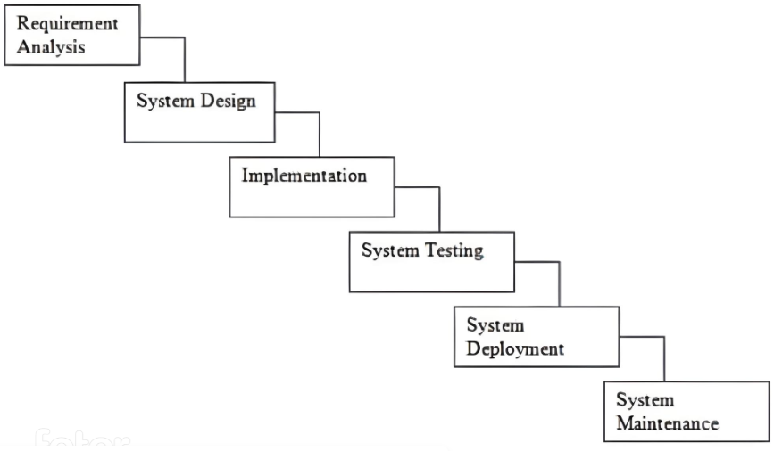

Figure 1.1: Waterfall Process Model

The sequential phases in Waterfall model are –

**Requirements gathering and analysis** - During this phase, all possible requirements for the system to be developed are collected and recorded in the requirements specification document.

**System Design and Implementation** - During this phase, the requirements specifications from the first phase are reviewed and the system design is completed. This technical design helps you determine hardware and system requirements and define the overall system architecture.

**Integration and testing** − All units developed during the implementation phase are integrated into the system after testing each unit. After integration, the entire system is checked for errors and failures.

**System Deployment** − Assets are deployed into the customer's environment or released to market after completing functional and non-functional testing.

**Maintenance** - In a customer environment, a number of challenges arise. Patches are released to fix the problem. In addition, better versions of the items are created to support the goods. Maintenance iscomplete to make these changes to the customer's environment.

**1.8 Reason for Choosing Waterfall Process Model**

The main reason behind choosing this model for my project is that it is a simple project and clear requirements for me to develop. For small projects it is used a lot and the requirements do not change often.

* Some of the main advantages of the waterfall model are:
* Simple and easy to understand and use
* Easy to manage thanks to the rigor of the model.
* Each stage has specific products and review processes.
* Stages are processed and completed at a time.
* Works well for small projects where the requirements are well understood.
* The timelines are clearly defined.

**1.9 Feasibility Study**

Feasibility assessment will consider the possibility of project implementation. A feasibility study is created to determine whether the project, when completed, will serve the organization's goals in terms of the level of work effort and therefore the time spent on it. A feasibility study allows the initiator to predict the long-term viability of the project and thereby predict its usefulness. Research the feasibility of a system proposal based on its feasibility, its impact on the organization, its ability to meet user needs, and its effective use of resources. Therefore, when an alternative application is proposed, a proof of concept is often performed before the development is approved. This document provides a secondary design and includes a list of possible options.

**1.9.1 Technical Feasibility**

The system must first be evaluated from a technological standpoint. The feasibility study should be supported by a high-level design of system requirements for inputs, outputs, programs and procedures. Once a combination is discovered, the investigation should continue to suggest the type of equipment, the method needed to build the system, and the method of operating the system once the system is designed.

At the same time, the process of using this application is very simple, ensuring users have sufficient technical proficiency to achieve the stated goal.

The project, entitled Car Service Management System, is technically feasible with the following that are readily, inexpensive, and well served.

Table 1.1: Software and Hardware Requirements

|  |  |  |
| --- | --- | --- |
| image20image21image22image23**SL** | image24image25**Hardware Requirements** | image26image27**Software Requirements** |
| image28image291 | image30Desktop Computer | image31OS (Any), Browser (Any) |
| image32image332 | Internet Support | image35PHP, Laravel, JavaScript, HTML5, CSS4, Authentication, API, REST  API, JSON |
| image36image373 | image3812GB system memory with 1TB HDD | image39 MySQL |

**1.9.2 Economic Feasibility**

Given the economical feasibility of the system I proposed, I properly analyzed and maintained the time. The cost of the system is flexible for the company. Employee time costs are reduced if the system is fully maintained by the organization. The estimated cost of hardware is about 40,000 taka & software is free.

**1.9.3 Operational Feasibility**

Even though I had spoken with my customer multiple times regarding the project's update, he stated his appreciation for the newly constructed system and expressed a need for it. If users have expressed a desire for a system that is available more of the time, is more efficient, and is more accessible, the chances are that the requested system will be employed ultimately. As a result, my project is developmentally realistic.

**Chapter 02**

**Organization Introduction**

**2.1 Organization Introduction**

Kodeeo Company Limited is a Bangladeshi company providing complete web solutions, software development, mobile applications, graphics and multimedia services, domain hosting and digital marketing. Its core consists of highly skilled designers and developers with over 5 years of experience in a variety of complex designs and developments. With services including website design and development, mobile application design and development, software development, SEO and social media design and development, Kodeeo Ltd. satisfy your customers. In all areas of our operations, we work hard to understand customer requirements and provide solutions Kodeeo Ltd. We strongly believe in the philosophy “Our vision is to help every young person become competent and employable”. We pride ourselves on our team of highly qualified, knowledgeable and motivated professionals who are encouraged for leadership, innovation and excellence. Our team is comprised of leading experts who share a common vision and passion, providing clients with the information and guidance needed to succeed in today's competitive environment. We believe in providing expert and excellent services through our experience and providing the best possible service utilization to our customers. (Kodeeo Company Limited).

**2.2 Organization Services**

Kodeeo Company Limited is a leading provider of IT services, including all types of creative and professional software, enterprise software integration, management information systems, e-commerce, game development Play and develop Web and mobile application solutions.

**2.2.1 Web Development**

At Kodeeo Ltd, we focus on creating interactive, search engine friendly website designs. It is a known fact that to build a strong web presence and ensure the countless marketing opportunities available on the Internet, it is mandatory to have a good website, thereby triggering a race in web design . While designing and developing your website, our experts keep in mind key factors such as ease of navigation, overall consistency and quality of content, stipulated deadlines and budgets as well as auxiliary support.

**2.2.2 Mobile Application**

We have a strong mobile application developer team of professional engineers who are experienced in creating versatile mobile applications for various industries. All our expert engineers work on Android and iOS platforms for more than 5 years. We work on stock Android, delivering faster app response and quality assurance. We can design, build, prototype and execute your ideas through planning, construction, testing and deployment.

**2.2.3 Digital Marketing**

Kodeeo Ltd offers different types of packages to help your business perform at its best in the internet world. Digital marketing involves promoting products or brands that are essential to the success of a business. It increases your web visibility among your potential customers. The more exposure you get, the closer you get to your business goals. This is the most important strategy to grow your business. Kodeeo Ltd is a full-service digital agency with clients ranging from well-known businesses to innovative startups. (Kodeeo Company Limited).

**2.3 Organization Vision**

Kodeeo Ltd's vision. is to empower youth and build successful IT businesses in digital Bangladesh. Their mission is to become one of the leading IT companies in Bangladesh. Through the innovative use of technology, Kodeeo Ltd. gain competitive advantage and increase operational effectiveness and efficiency.

**2.4 Organization Mission**

Kodeeo Ltd. was established as a one-stop shop for a skills development platform. Client needs are satisfied in respect to their attributes thanks to their services and the excellent staff behind them.

My position in this organization I am a development intern in this organization. I am guided by a supervisor in this organization. It was very helpful and informative. I really learned a lot from him. I completed my project on time. This was only possible thanks to the advice of my supervisor. It was also a great experience for me to maintain working time at the office. I also followed other organizing instructions. I am happy to be a part of this office. It definitely helped prepare me for the start of my career.

**2.5 Organization Location**

House 15 Road-10 A, Sector 11, Dhaka 1230

Phone: 01854969657

Email: info@kodeeo.com

Web: www.kodeeo.com

**Chapter 03**

**Requirement Engineering**

**3.1 Requirements Analysis**

Requirements analysis is a type of software engineering job that connects systems engineering with systems design. Requirements analysis allows programmers to identify and create models of information domains, functions, and behaviors for the software to process. The first step in the software development process is requirements analysis. It includes all the tasks involved in determining the requirements or conditions to be met for a replacement or modified product.

There are 6 phases which is described below:

**Requirement Initiation:** Myproject entitled “Car Service Management System”.

**Requirement Elicitation:** Communicators will take into account all their requirements and ensure that they understand the implications of the new systems. I also try to understand the user's needs as well as the limitations of the system. I looked at the user's work. Mainly two works:

* Analyze the Requirement
* Recording User Requirements

**Requirement Elaboration:** This is the process of gathering information about user requirements and limitations. How will the entities in the system interact with each other.

**Requirement Negotiation:** Here we negotiating with the customer regarding the cost of software and other equipment provided to the system.

**Requirement Specification:** The behavior of the system to be developed is described in detail in a software requirements specification (SRS). At this point, I described the manpower and technology needs for the system's deployment.

**3.2 Requirement Engineering**

Requirements is the technical field of creating user requirements and specifying the software system, as the name suggests. Specifications have many definitions. However, they share the idea that requirements include an understanding of what requirements mean from a design perspective.

There are four type of requirement:

1. User Requirements

2. System Requirements

3. Functional Requirements

4. Non-Functional Requirements

**3.2.1 User Requirements**

Here user requirements I have taken under consideration while doing ‘Car service management system’. The user requirements are:

1. There should be login page.
2. Admin can login.
3. Customer can login.
4. Admin can manage the car categories.
5. Admin can manage the car brand.
6. Admin can view the user table and also can take action.
7. Mechanic center can login.
8. Mechanic can create service.
9. Admin can take action against service request.
10. Admin and Mechanic view the category.
11. Admin and Mechanic can view the brand.
12. Admin can provide billing report to the customer.
13. Admin can update profile.
14. Customer can login.
15. Customer can send booking request.
16. Customer can take action after sending booking request before service center take action.
17. Customer can payment.
18. Customer can view bookings.
19. Customer can contact with mechanics by message.
20. Customer can print report.

**3.2.2 System Requirement**

1. System can provide customer info.
2. System can provide service center information.
3. System provide the category list.
4. System provide the list of tables if they are available or not
5. System provide the list of all brand information.
6. System provide service list.
7. System provide booking information.
8. System provide a reports.
9. System should be able to edit, add and update all the given information
10. System should have company information

**3.2.3 Functional Requirement**

1. Admin manage all the category.
2. Admin manage all brand.
3. Admin manage the users.
4. Admin edit his own info
5. Admin manage the service.
6. Admin manage the customer request.
7. Admin should be able to edit company’s information.
8. Customr should be able to edit his own info.
9. Customer should be able to view all the service, category and brand.
10. Customer should be able to book the service.

**3.2.4 Non-Functional Requirement**

1. Production Requirements: Car service management should be available in both pc and mobile platforms as well as running on any OS.
2. Organizational Requirements: Only admin can add or remove user, brand and category.
3. External Requirements: System should the trustable for ensuring complete privacy for all of its users.

**3.3 Use Case Diagram**

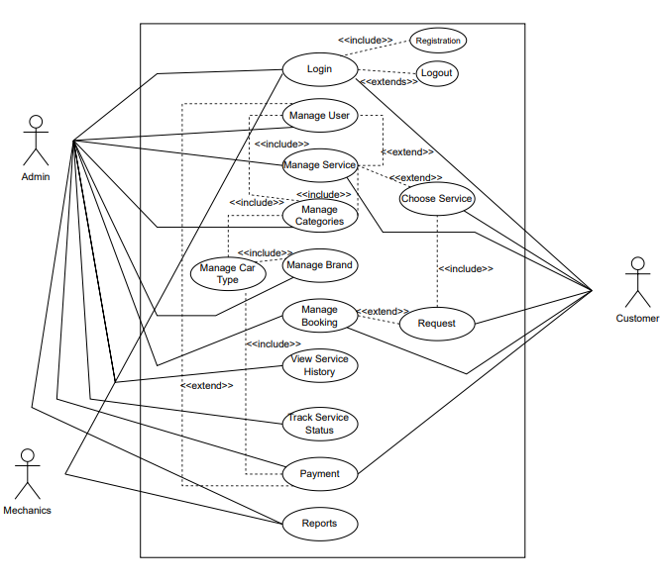

Figure 3.1: Use Case Diagram

**Chapter 04**

**System Planning**

**4.1 Functions of the Proposed System**

Functions of the proposed system “Car Service Management System” are given below :

Table 4.1: Functions of the project

|  |  |  |
| --- | --- | --- |
| **SL** | **Functions** | **Synonym** |
| 1 | Authentication (Registration & Login) | F1 |
| 2 | Registration for Service Center | F2 |
| 3 | Registration for Customer | F3 |
| 4 | Manage Category | F4 |
| 5 | Manage Brand | F5 |
| 6 | Manage Users | F6 |
| 7 | Manage Service | F7 |
| 8 | Manage Contact | F8 |
| 9 | Manage Booking | F9 |
| 10 | Manage Report | F10 |

**4.2 System Project Planning**

We need to keep in mind the time it takes to complete our project. The second activity of CPF is software project planning. Software project management begins with a series of activities collectively known as software project planning. Through software project planning, we estimate the work to be done, the resources needed, the time elapsed from start to finish, and finally analyze the project to determine whether it is feasible or not.

I have performed the following software project planning activities:

* System Project Estimation
* Function Oriented Metrics
* Process Based Estimation
* Task Scheduling
* Project Schedule Chart
* Cost Estimation

**4.2.1 System Project Estimation**

The accuracy of a software project estimate predicated based on a number of things. They are-

* Carefully estimate the dimensions of the product to be built.
* Ability to convert scale estimates into human effort, time and money.
* The extent to which the project plan reflects the capabilities of the software team.
* Stability of product requirements and the environment that supports the software development effort.

The most important aspect of a software project that I have to deal with is estimating the size of the software. If the software size is not calculated correctly, it will lead to various problems such as planning problems, budget problems, etc.

**4.2.2 Function Oriented Metrics**

The following are the information domain values:

**Number of external inputs (EI)** – User inputs that provide application-specific relevant data to the software are counted as inputs to distinguish them from requests.

**Number of external inquiries (EQ)** – Requirements are described as online inputs that lead to the development of online results in the form of software responses. Each request is counted separately.

**Number of Internal logical files (ILF)** - Each logical key file is counted separately. Database table in which the application modifies form entries.

**Numbers of external interfaces files (EIF)** - All machine-readable interfaces that have previously sent information to another system are counted.

**Functional Complexity:** The complexity matrices are listed below:

Table 4.2: Complexity Metrics for External Input (EI)

|  |  |  |  |
| --- | --- | --- | --- |
| **EI** | **1-4 DETs** | **5-15 DETs** | **16 or more DETs** |
| 1 FTRs | Low | Low | Average |
| 2FTRS | Low | Average | High |
| 3 or more FTRs | Average | High | High |

Table 4.3: Complexity Metrics for External Output and External Queries (EO / EQ)

|  |  |  |  |
| --- | --- | --- | --- |
| **EO/EQ** | **1-5 DETs** | **6-19 DETs** | **20 or more DETs** |
| 1 FTRs | Low | Low | Average |
| 2-3 FTRs | Low | Average | High |
| 4 or more FTRs | Average | High | High |

Table 4.4: Complexity Metrics for Internal Logical File and External Interface File

|  |  |  |  |
| --- | --- | --- | --- |
| **ILF/EIF** | **1-19 DETs** | **20-50 DETs** | **51 or more DETs** |
| 1 RETs | Low | Low | Average |
| 2-5 RETs | Low | Average | High |
| 6 or more FTRs | Average | High | High |

**Functional Component Complexity Weight Assignment**

Table 4.5: Complexity Weight Assignment for Transaction Functions

|  |  |  |
| --- | --- | --- |
| **Complexity** | **Transaction Function Types** | |
| **EI/EQ** | **EO** |
| Low | 3 | 4 |
| Average | 4 | 5 |
| High | 6 | 7 |

Table 4.6: Complexity Weight Assignment for Data Functions

|  |  |  |
| --- | --- | --- |
| **Complexity** | **Data Function Types** | |
| **ILF** | **EIF** |
| Low | 7 | 5 |
| Average | 10 | 7 |
| High | 15 | 10 |

**Identifying Complexity for Transition Functions**

Table 4.7: Complexity Identification of Transition Functions

|  |  |  |  |
| --- | --- | --- | --- |
| **Transition Function** | **Fields/File Involvement** | **FTRs** | **DETs** |
| Registration (EI) | Fields: Email, Password Files: Users | 1 | 2 |
| Login (EI) | Fields: Email, Password Files: Users | 1 | 2 |
| Profile Update (EI) | Fields: Name, Phone, Email, Address, Password, Image, Country  Files: Users | 1 | 7 |
| Profile View (EO) | Fields: Name, Phone, Email, Address, Image  Files: Users | 1 | 5 |
| Category View (EO) | Fields: Name, Status Files: Category | 1 | 2 |
| Category Add (EI) | Fields: Name, Description, Status, Image Files: Category | 1 | 4 |
| Category Update (EI) | Fields: Name, Description, Status, Image Files: Category | 1 | 4 |
| Category Delete (EI) | Fields: Name, Description, Status, Image Files: Category | 1 | 4 |
| Brand View (EO) | Fields: Brand Name, Description, Status, Image  Files: Brand | 1 | 4 |

|  |  |  |  |
| --- | --- | --- | --- |
| Brand Add (EI) | Fields: Brand Name, Description, Status, Image Files: Brand | 1 | 4 |
| Brand Update (EI) | Fields: Brand Name, Description, Status, Image Files: Brand | 1 | 4 |
| Brand Delete (EI) | Fields: Brand Name, Description, Status, Image Files: Brand | 1 | 4 |
| Service View (EO) | Fields: Service Name, Price Files: Service, Users | 2 | 2 |
| Service Add (EI) | Fields: Service Name, Service Center Id, Price, Status, Image, Description  Files: Service, Users | 2 | 6 |
| Service Update (EI) | Fields: Service Name, Service Center Id, Price, Status, Image, Description  Files: Service, Users | 2 | 6 |
| Service Delete (EI) | Fields: Service Name, Service Center Id, Price, Status, Image, Description  Files: Service, Users | 2 | 6 |
| Service Center View (EO) | Fields: Name, Phone, Location, Email Files: Users | 1 | 4 |
| Customer View (EO) | Fields: Name, Image, Address, Email, Password, Country, Role  Files: Users | 1 | 7 |
| Customer Add (EI) | Fields: Name, Image, Address, Email, Password, Country, Role  Files: Users | 1 | 7 |
| Customer Update (EI) | Fields: Name, Image, Address, Email, Password Files: Users | 1 | 5 |

|  |  |  |  |
| --- | --- | --- | --- |
| Customer Delete (EI) | Fields: User ID Files: Users | 1 | 1 |
| Service Center Add (EI) | Fields: Name, Image, Address, Email, Password, Country, Role  Files: Users | 1 | 7 |
| Service Center Update (EI) | Fields: Name, Image, Address, Email, Password, Country, Role  Files: Users | 1 | 7 |
| Service Center Delete (EI) | Fields: User ID Files: Users | 1 | 7 |
| Booking Add (EI) | Fields: Customer Name, Service, Service Center, Price, Payment, Status, User ID, Brand ID, Model, Request, Address, Address 1, Transaction ID  Files: Users, Brand, Service, Booking | 4 | 13 |
| Booking View (EO) | Fields: Customer Name, Service, Service Center, Price, Payment, Status, User ID, Brand ID, Model, Request, Address, Address 1, Transaction ID  Files: Users, Brand, Service, Booking | 4 | 13 |
| Booking Update (EI) | Fields: Model, Request, Address 1 Files: Users, Booking | 2 | 3 |
| Booking Delete (EI) | Fields: Customer Name, Service, Service Center, Price, Payment, Status, User ID, Brand ID, Model, Request, Address, Address 1, Transaction ID  Files: Users, Brand, Service, Booking | 4 | 13 |
| Contact View (EO) | Fields: Name, Email, Phone, Description Files: Contact | 1 | 4 |
| Contact Message Add (EI) | Fields: Name, Email, Phone, Description Files: Contact | 1 | 4 |

**Identifying Complexity for Data Function**

Table 4.8: Complexity Identification of Data Function

|  |  |  |  |
| --- | --- | --- | --- |
| Data Function | Fields/File Involvement | RETs | DETs |
| Users (ILF) | Fields: Name, Email, Phone, Address, Password, Role, Country, Image  Files: Customer, Admin, Mechanic | 3 | 8 |
| Category (ILF) | Fields: Name, Status, Description, Image  Files: Category | 1 | 4 |
| Brand (ILF) | Fields: Name, Status, Description, Image  Files: Brand | 1 | 4 |
| Service (ILF) | Fields: Service Name, Price, Status, Image, Description  Files: Service, User | 2 | 5 |
| Service Center  (ILF) | Fields: User ID  Files: User | 1 | 1 |
| Booking (ILF) | Fields: Customer Name, Service, Service Center, Price, Payment, Status, User ID, Brand ID, Model, Request, Address, Address 1, Transaction ID  Files: Users, Brand, Service, Booking | 4 | 13 |
| Contact (ILF) | Fields: Name, Email, Phone, Description Files: Contact | 1 | 4 |

**Unadjusted Function Point Contribution**

Table 4.9: Unadjusted Function Point Contribution (Transition Function)

|  |  |  |  |  |
| --- | --- | --- | --- | --- |
| Transition Function | FTRs | DETs | Complexity | UFP |
| Registration (EI) | 1 | 2 | Low | 3 |
| Login (EI) | 1 | 2 | Low | 3 |
| View Profile (EO) | 1 | 5 | Low | 4 |
| Update Profile (EI) | 1 | 7 | Low | 3 |
| View Category (EI) | 1 | 2 | Low | 3 |
| Add/Delete/Update Category (3 x EI) | 1 | 4 | 3x Low | 9 |
| View Brand (EO) | 1 | 4 | Low | 4 |
| Add/Delete/Update Brand  (3 x EI) | 1 | 4 | 3x Low | 9 |
| Add/Delete/Update Customer (3 x EI) | 1 | 7 | 3x Low | 9 |
| View Service (EO) | 2 | 2 | Low | 4 |
| Add/Delete/Update Service Center (3 x EI) | 2 | 6 | 3x Average | 12 |
| Add/Delete/Update Booking (3 x EI) | 4 | 13 | 3x High | 18 |
| Add/Delete Contact  (2 x EI) | 1 | 4 | 2x Low | 6 |
| Total | | | | 87 |

Table 4.10: Unadjusted Function Point contribution (Data Function)

|  |  |  |  |  |
| --- | --- | --- | --- | --- |
| Data Function | RETs | DETs | Complexity | UFP |
| Users (ILF) | 3 | 8 | Low | 7 |
| Category (ILF) | 1 | 4 | Low | 7 |
| Brand (ILF) | 1 | 4 | Low | 7 |
| Service (ILF) | 2 | 5 | Low | 7 |
| Service Center (ILF) | 1 | 1 | Low | 7 |
| Booking (ILF) | 4 | 13 | Low | 7 |
| Contact (ILF) | 1 | 4 | Low | 7 |
| Total | | | | 49 |

**Total Degree of Influence (TDI)**

Table 4.11: Degree of Influence

|  |  |  |
| --- | --- | --- |
| **SL** | **GSC** | **DI** |
| 1 | Data Communications | 3 |
| 2 | Distributed Data Processing | 0 |
| 3 | Performance | 3 |
| 4 | Heavily Used Configuration | 2 |
| 5 | Transaction Rate | 2 |
| 6 | Online Data Entry | 3 |
| 7 | End-User Efficiency | 4 |
| 8 | Online Update | 0 |
| 9 | Complex Processing | 1 |
| 10 | Reusability | 0 |
| 11 | Installation Ease | 2 |
| 12 | Operational Ease | 2 |
| 13 | Multiple Sites | 0 |
| 14 | Facilitate Change | 0 |
| **Total** | | **22** |

TDI (Range 0 to 70) Influence size by +/- 22% = 22

**Adjusted Function Point Calculation**

VAF = (0.65 + (0.01 * TDI))

= (0.65 + (0.01 * 22))

= 0.87

Now,

UFP = UFP (Transition Functions) + UFP UFP = 87 + 49

UFP = 136

Theproject is developed in PHP Laravel. Hours per Function Point of PHP is 15.5. Each person will work 8 hours per day.

So, Effects for PHP = AFP*Productivity

≈ 136 x 15.5

≈ 2108 per hour

12 hour person/per day = 2108/12

= 175.6 days

Approximate 176 days

In a group, there are 1 member

Total days=74

= 20 days Working of a month

= 74/20

=3.7 months

**4.2.3 Process Based Estimation**

In this section I show that in which particular part take how much time & percentage to complete the whole system: The estimation table given below:

Table 4.12 Process Based Estimation

|  |  |  |  |  |  |  |  |  |
| --- | --- | --- | --- | --- | --- | --- | --- | --- |
| **Activity** | **CC** | **Planning** | **Engineering** | | **Construction** | | **Implementation** | **Total** |
| **Function** | **Analysis** | **Design** | **Code** | **Test** |
| **F1** | 0.020 | 0.060 | 0.320 | 0.600 | 0.600 | 0.085 | 0.085 | 1.805 |
| **F2** | 0.020 | 0.030 | 0.250 | 0.350 | 0.555 | 0.060 | 0.060 | 1.325 |
| **F3** | 0.023 | 0.065 | 0.210 | 0.450 | 0.600 | 0.085 | 0.065 | 1.482 |
| **F4** | 0.018 | 0.055 | 0.190 | 0.510 | 0.540 | 0.070 | 0.070 | 1.493 |
| **F5** | 0.025 | 0.055 | 0.300 | 0.690 | 0.600 | 0.080 | 0.080 | 1.835 |
| **F6** | 0.016 | 0.065 | 0.265 | 0.550 | 0.510 | 0.070 | 0.080 | 1.611 |
| **F7** | 0.095 | 0.045 | 0.310 | 0.460 | 0.590 | 0.080 | 0.070 | 1.735 |
| **F8** | 0.035 | 0.030 | 0.260 | 0.510 | 0.630 | 0.065 | 0.065 | 1.620 |
| **F9** | 0.020 | 0.050 | 0.190 | 0.340 | 0.540 | 0.050 | 0.044 | 1.414 |
| **F10** | 0.035 | 0.023 | 0.160 | 0.220 | 0.340 | 0.030 | 0.015 | 0.823 |
| **Total** | **0.336** | **0.513** | **2.52** | **4.460** | **5.435** | **0.619** | **0.659** | **12.961** |
| **Effort** | **2.17%** | **3.40%** | **16.75%** | **33.19%** | **35.15%** | **4.71%** | **4.63%** | **100%** |

**4.2.4 Task Scheduling**

When it comes to project scheduling, there are a few basic guidelines to follow.

They are as follows–

**Compartmentalization** – Projects should be broken down into manageable activities and tasks.

**Interdependence** – First need to determine the interdependence of each subdivided activity or task. Some tasks need to be run sequentially, while others can be run in parallel.

**Defined responsibilities** – Every scheduled task should be assigned to a specific team member.

**Defined outcomes** – Every planned task should have a clear goal in mind. Typically, the result is a work product or part of a work product.

**4.2.5 Project Scheduling Chart**

The following is a timeline for this project:

Table 4.13: Project Scheduling Chart

|  |  |  |  |  |  |  |  |  |  |  |  |  |  |  |  |  |
| --- | --- | --- | --- | --- | --- | --- | --- | --- | --- | --- | --- | --- | --- | --- | --- | --- |
| Week Activities | W 1 | W 2 | W 3 | W 4 | W 5 | W 6 | W 7 | W 8 | W 9 | W 10 | W 11 | W 12 | W 13 | W 14 | W 15 | W 16 |
| Requirements Analysis |  | |  |  |  |  |  |  |  |  |  |  |  |  |  |  |
| System Design |  |  |  | | | | |  |  |  |  |  |  |  |  |  |
| Implementation |  |  |  |  |  |  |  |  | |  |  |  |  |  |  |  |
| Testing |  |  |  |  |  |  |  |  |  |  |  |  |  |  |  |  |
| Deployment |  |  |  |  |  |  |  |  |  |  |  | | | | | |

**4.2.6 Cost Estimation**

To estimate the cost for my project & several type of cost have to develop a system. Like software, hardware, personal & other cost have for a development a system.

**4.2.6.1 Personnel Cost**

Need to developded the project = 90 days Holiday = 30 days

Working days = 90-30

= 60 days

Per months to develop = 60/3

= 20 days

Per day work = 8 hours

Working hours every month = 20*8

= 160 hours

Table 4.14: Personnel cost

|  |  |  |  |
| --- | --- | --- | --- |
| **Type** | **Members** | **Duration** | **Honorarium** |
| Analyst & Designer | 1 | 3 Months | 20,000 BDT |
| Developer | 1 | 3 Months | 20,000 BDT |
| Tester | 1 | 3 Months | 15,000 BDT |
| **Total** | | | **55,000 BDT** |

**4.2.6.2 Hardware Cost**

Cost of the computers that was used to complete the project:

Table 4.15: Hardware Cost

|  |  |  |  |  |  |
| --- | --- | --- | --- | --- | --- |
| **Device** | **Quantity** | **Price** | **Lifetime** | **Using Year** | **Deprecation**  **Cost** |
| Core i5  Desktop | 3 | 55,000/= | 5 Years | 3rd Year | 3*(55,000*20%)  = 66,000 BDT |
| **Total** | | | | | **33,000 BDT** |

**4.2.6.3 Software Cost**

Table 4.16: Software Cost

|  |  |
| --- | --- |
| **Description** | **Price** |
| Windows OS | Free |
| VS Code Editor | Free |
| Others | Free |
| **Total** | **0 BDT** |

**4.3 Costing**

Table 4.18: Accounts Table

|  |  |
| --- | --- |
| **Description** | **Cost** |
| Personal Cost | 55,000 BDT |
| Hardware Cost | 33,000 BDT |
| Software Cost | Free |
| Other Cost | 17,000 BDT |
| **Total Cost** | **105,000 BDT** |

**Chapter 05**

**Risk Management**

**5.1 Risk Management**

In the Car service Management project, we used risk management techniques to identify, mitigate, manage and control the risk that may occur during the process of software building or those that follows afterwards. We are attempting to identify the hazards that may arise throughout the project's development in this project. Additionally, attempt to come up with a means to avoid such risks, and if they do occur, devise a plan to mitigate the harm.

**5.2 Risk Process Model**

For Restaurant Management System these are the four steps we will deal with in risk engineering:

* Risk Identification
* Risk Analysis
* Risk Planning
* Risk Monitoring

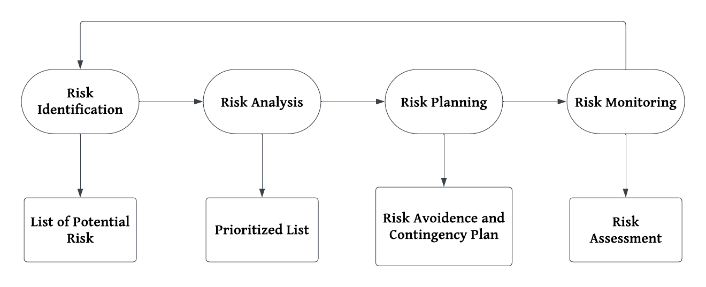

Figure 5.1: Risk Management Process

**5.3 Risk Identification**

Table 5.1: Risk Identification Table

|  |  |
| --- | --- |
| **Risk Type** | **Possible risks** |
| People | 1. Team members may struggle to comprehend the provided requirements. 2. During the project's progress, any member may become ill. 3. It's possible that the group's required training will be unavailable.   5) The group members' lack of experience.  4) There is a lack of communication among the members of the organization. |
| Technology | 1. It's possible that the database won't be able to handle many entries at the same time. 2. The system's fundamental modules may have dependency-related issues, which reduces the system's reusability. 3. The processing power of the available workstations may not be sufficient to complete the job. |
| Requireme  nts | 1. Requirements may change after the construction of fundamental features,   necessitating a complete rewrite of the entire system's functionality.   1. A requirement change may be proposed that affects the entire system components' internetwork. |
| Estimation | 1. The project's estimated development time may be shorter than anticipated. 2. The budgeted amount may not be sufficient for the entire project's development. |

**5.4 Risk Analysis, Planning and Monitoring**

Table 5.2: Risk Analysis Table

|  |  |  |  |  |  |  |
| --- | --- | --- | --- | --- | --- | --- |
| **Possible Risks** | | **Probabilit**  **y** | **Status** | **Impact** | **Mitigation**  **and** | |
| 1. Insufficient  training for Staffs | | 15% | Did not Occur | Tolerable | Inexperienced members may  guided by | be more |
| 2. Group might be  unavailable | members ill or | 35% | Resolved | Tolerable | Distribute the workload among the group members  who are available. | |
| 3. Estimated budget  may be lower than required | | 40% | Did not Occur | Catastrophic | It's possible that reducing  functionalities will be beneficial. | |
| 4. Estimated time maybe be less than  required | | 55% | Resolved | Catastrophic | To ensure productivity,  hold regular meetings. | |
| 5. Size of the software might be  underestimated | | 25% | Resolved | Serious | Development should begin when the entire process has been  thoroughly examined. | |
| 6. Defect repair is  underesti | | 25% | Resolved | Serious | To detect bugs faster, code should be  thoroughly documented. | |
| 7. Database may show slower execution | | 25% | Did not | Serious | Move to a  database system | faster  if |
| 8. Lack of necessary  utilities | | 25% | Did not  occur | Tolerable | Use cloud resources or  re- plan budget | |
|  | | | | | | |

**Chapter 06**

**Analysis Modeling**

**6.1 Analysis Modeling**

Analysis modeling is the system's necessary diagram, which helps developers understand the workflow and create the project in a systematic manner. Analysis modeling consists of:

* Activity Diagram
* Data Flow Diagram
* Entity Relationship Diagram

**6.2 Activity Diagram**

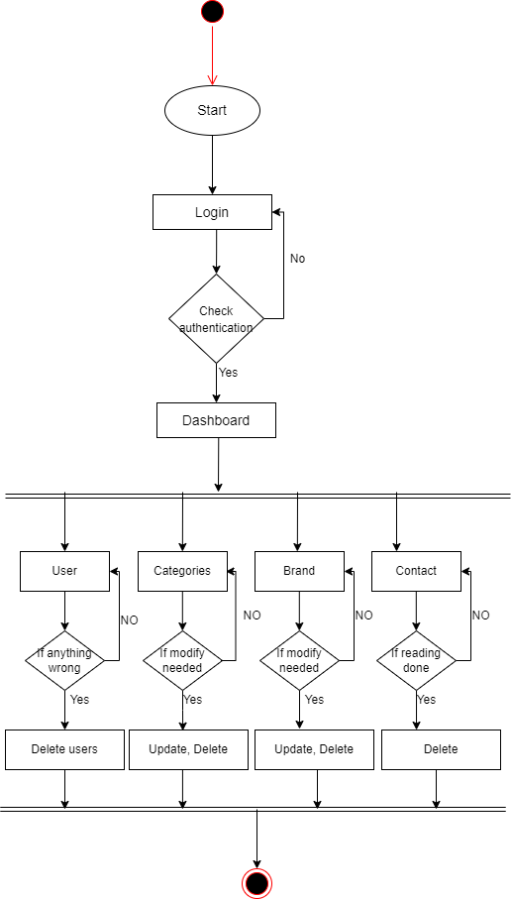 **6.2.1 Activity Diagram for Admin**

Figure 6.1: Activity Diagram for Admin

**6.2.2 Activity Diagram for Mechanic**

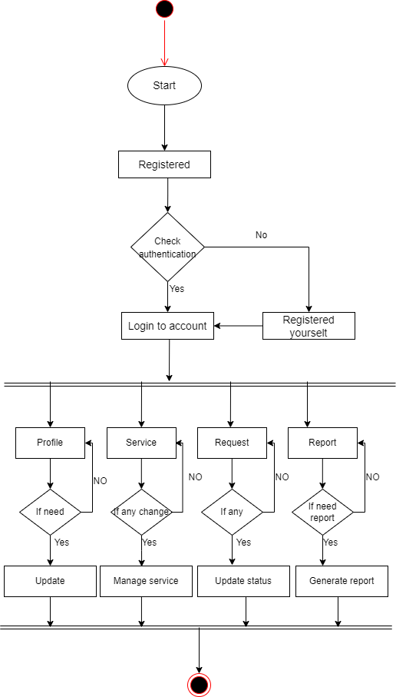

Figure 6.2: Activity Diagram for Mechanic

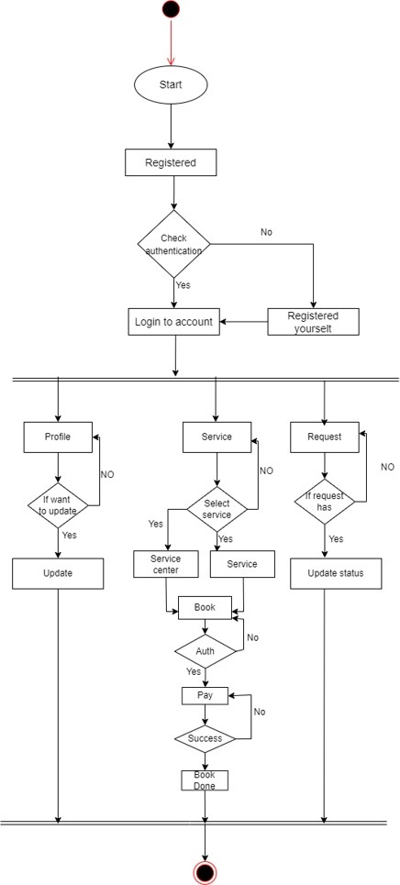**6.2.3 Activity Diagram for Customer**

Figure 6.3: Activity Diagram for Customer

**6.3 Data Flow Diagram**

**6.3.1 Context Level DFD**

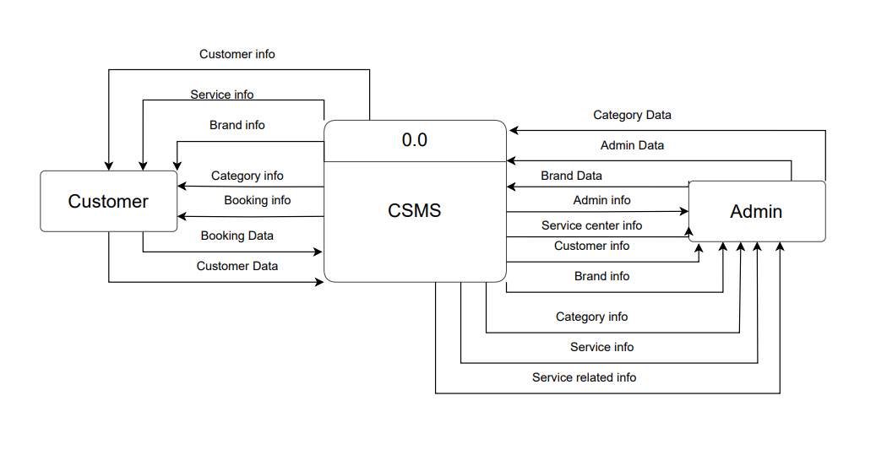

Figure 6.4: Context Level DFD

**6.3.2 Level 1 DFD**

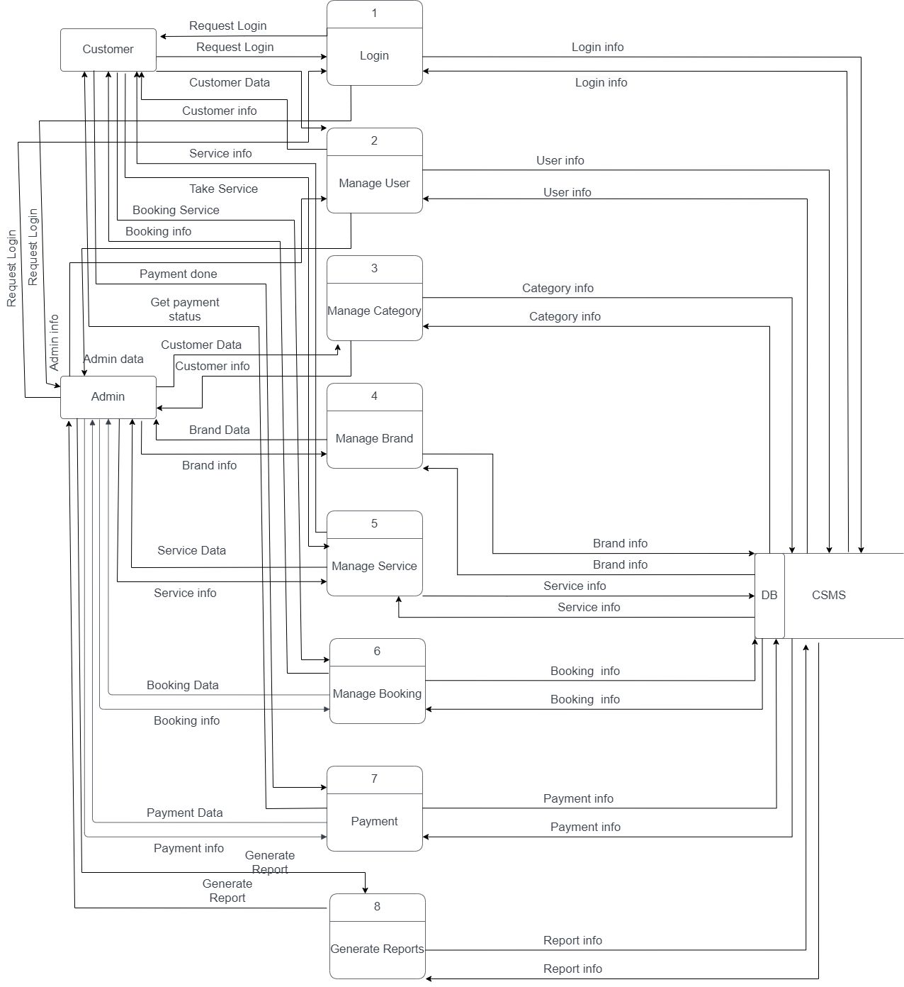

Figure 6.5: Level 1 DFD

**6.4.1 Level 2 DFD Process (User Login)**

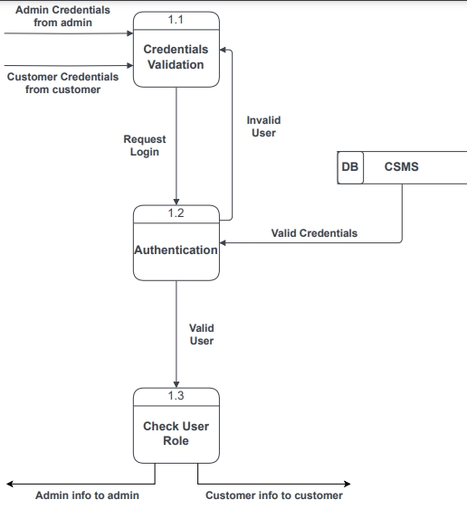

Figure 6.6: Level 2 DFD Process 1 (User Login)

**6.4.2 Level 2 DFD Process 2 (Manage User)**

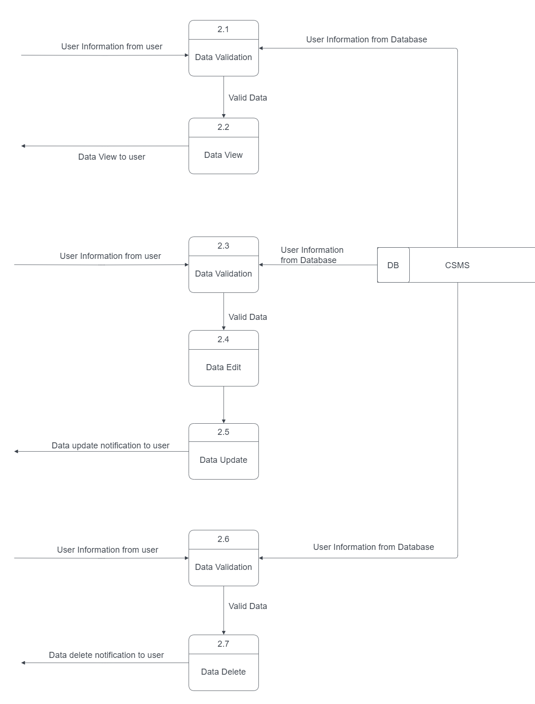

Figure 6.7: Level 2 DFD Process 2 (Manage User)

**6.4.3 Level 2 DFD Process 3 (Manage Category)**

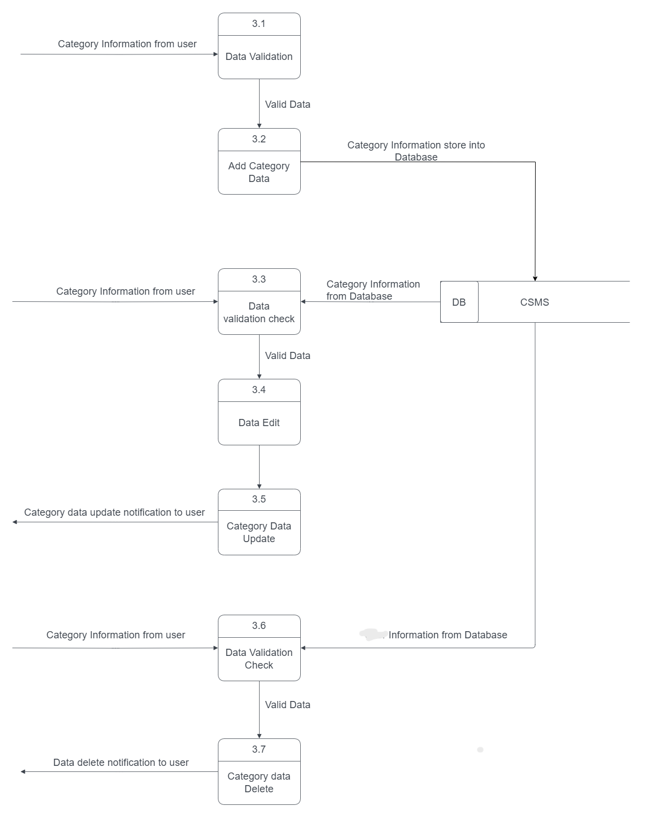

Figure 6.8: Level 2 DFD Process 3 (Manage Category)

**6.4.3 Level 2 DFD Process 4 (Manage Brand)**

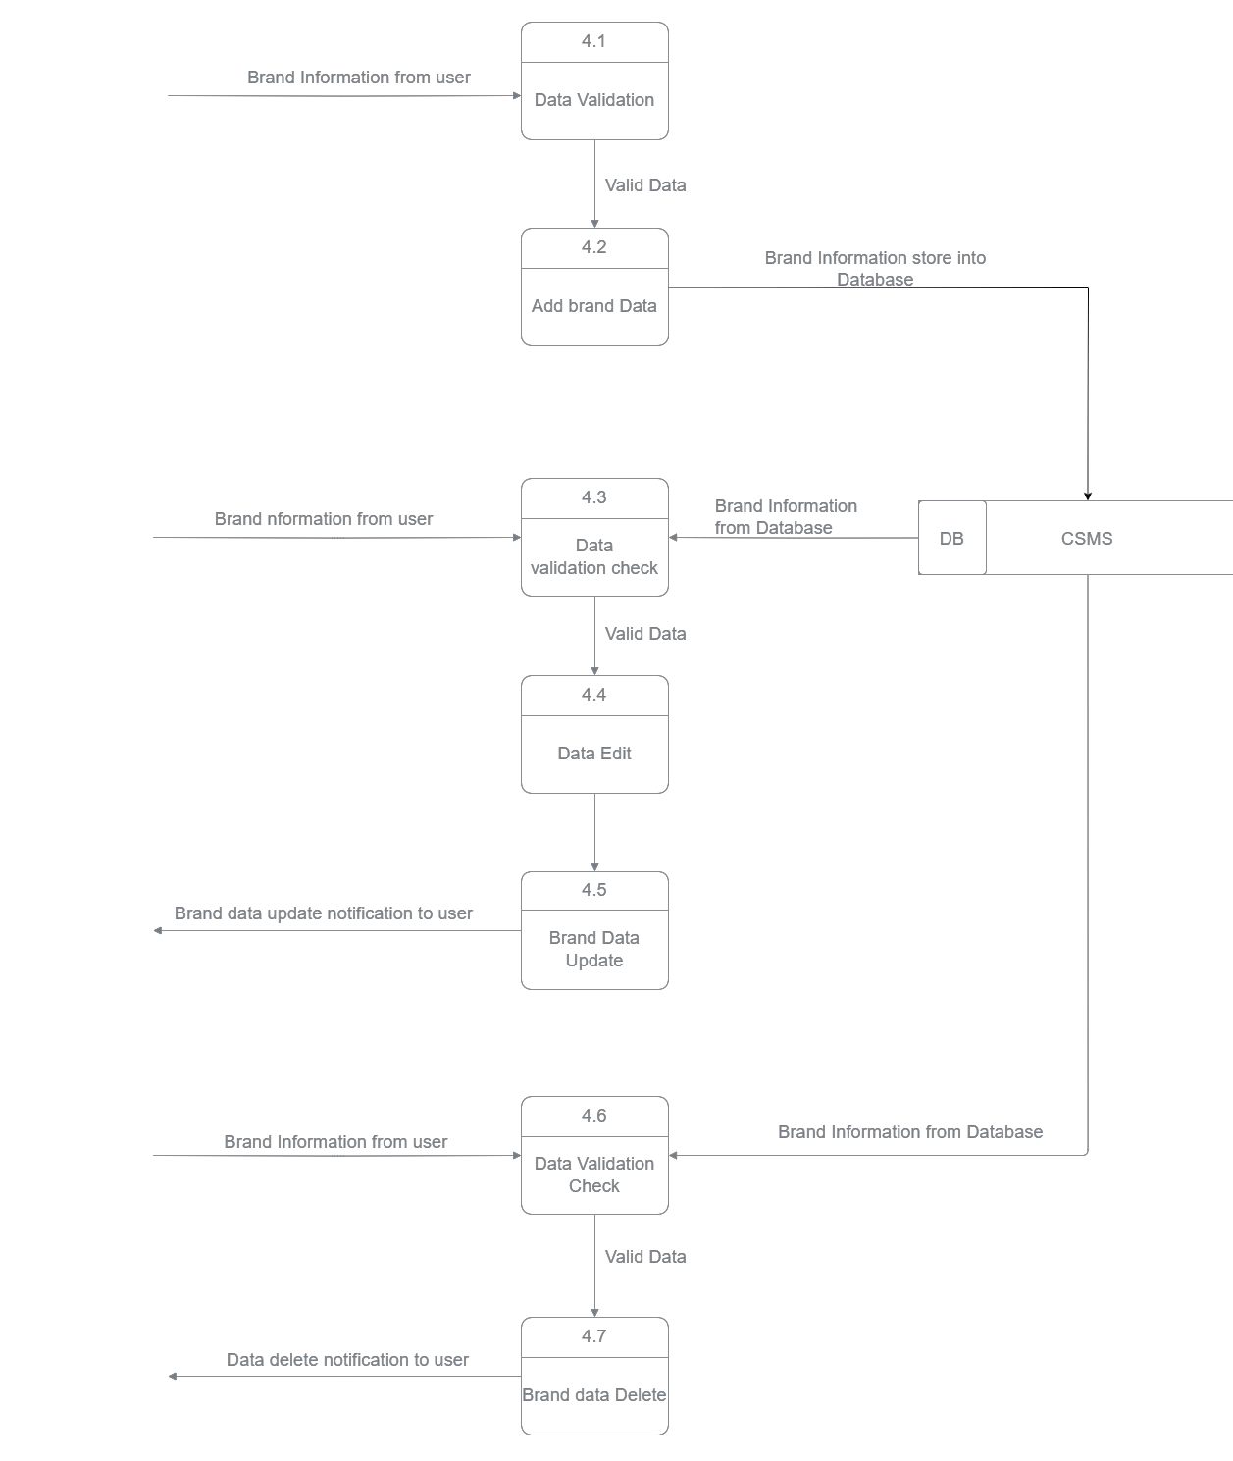

Figure 6.9: Level 2 DFD Process 5 (Manage Service)

**6.4.5 Level 2 DFD Process 5 (Manage Service)**

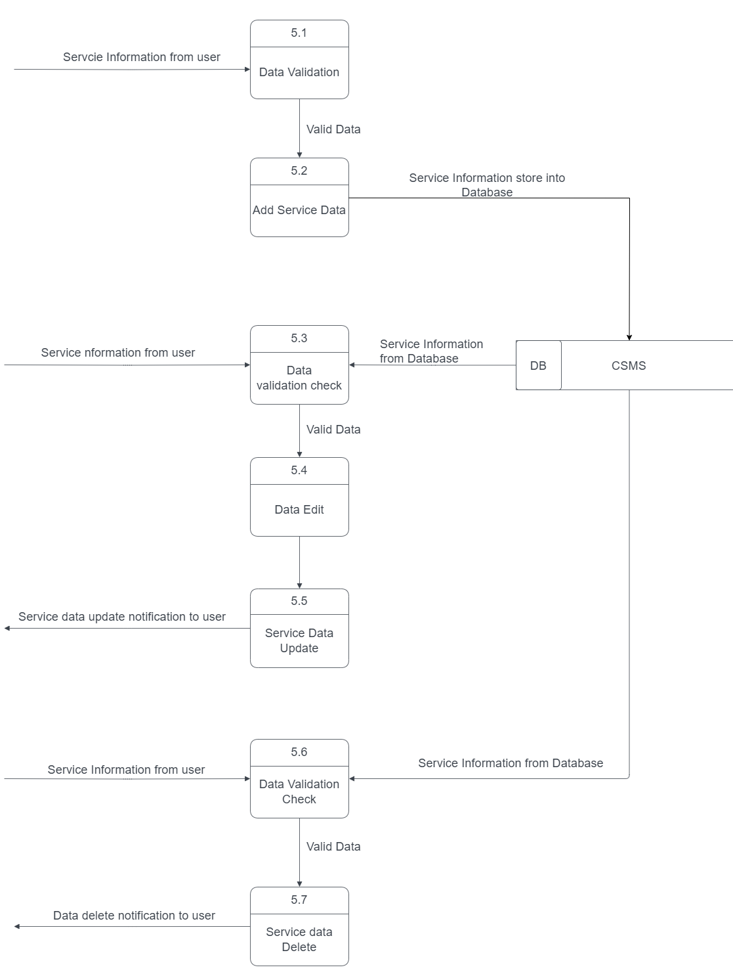

Figure 6.10: Level 2 DFD Process 5 (Manage Service)

**6.4.6 Level 2 DFD Process 6 (Manage Booking)**

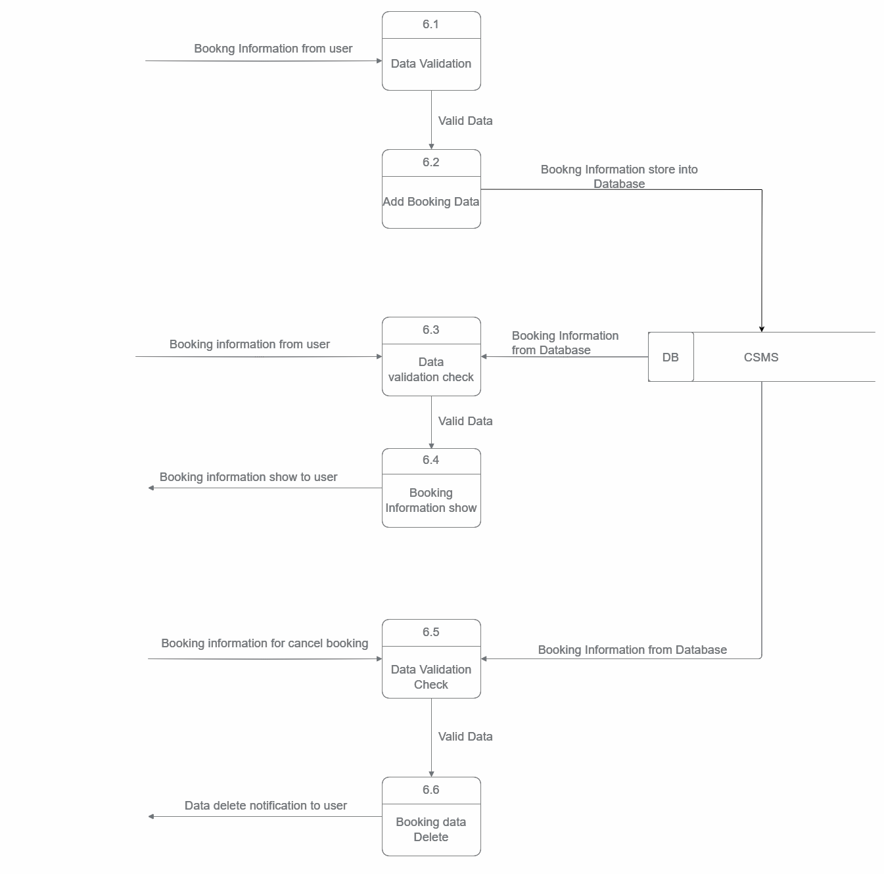

Figure 6.11: Level 2 DFD Process 6 (Manage Booking)

**6.4.7 Level 2 DFD Process 7 (Generate Report)**

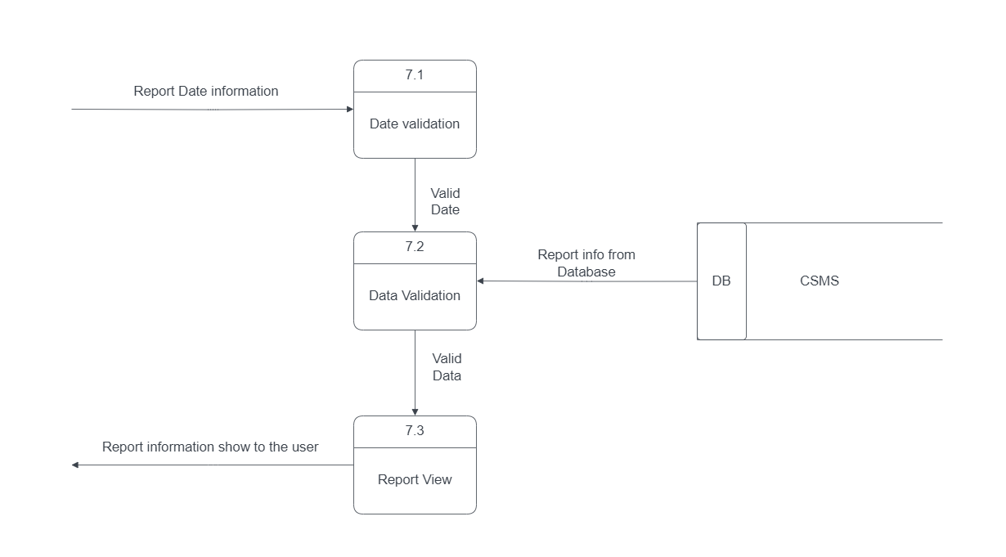

Figure 6.12: Level 2 DFD Process 7 (Generate report)

**6.5 Entity Relationship Diagram**

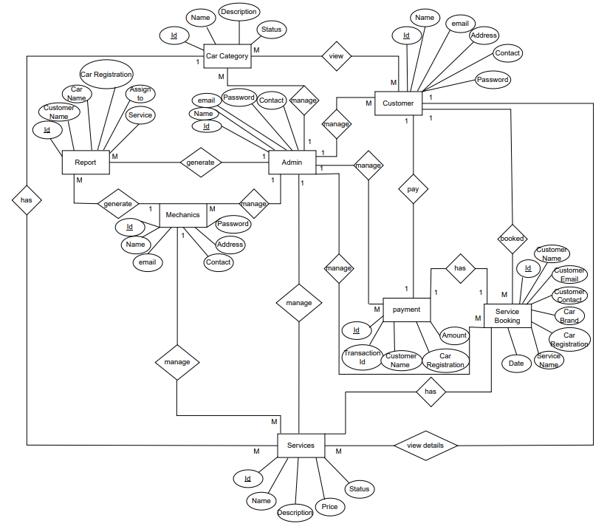

Figure 6.13: Entity Relationship Diagram

**Chapter 07**

**Designing**

**7.1 Database Schema Design**

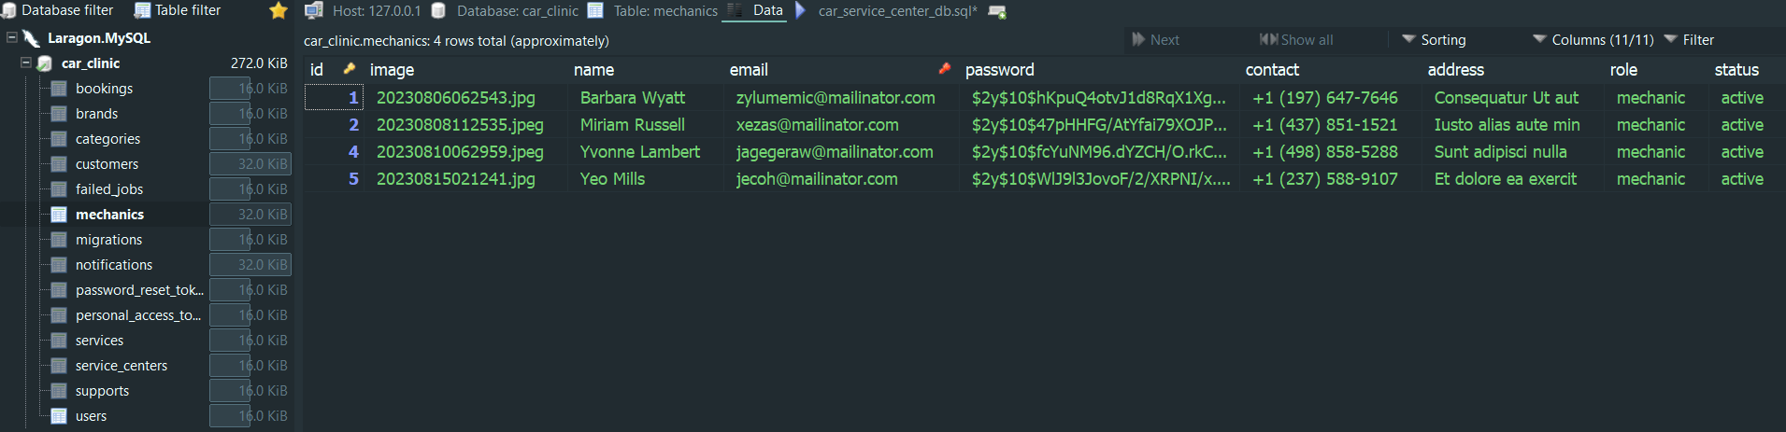

Figure 7.1: User Table

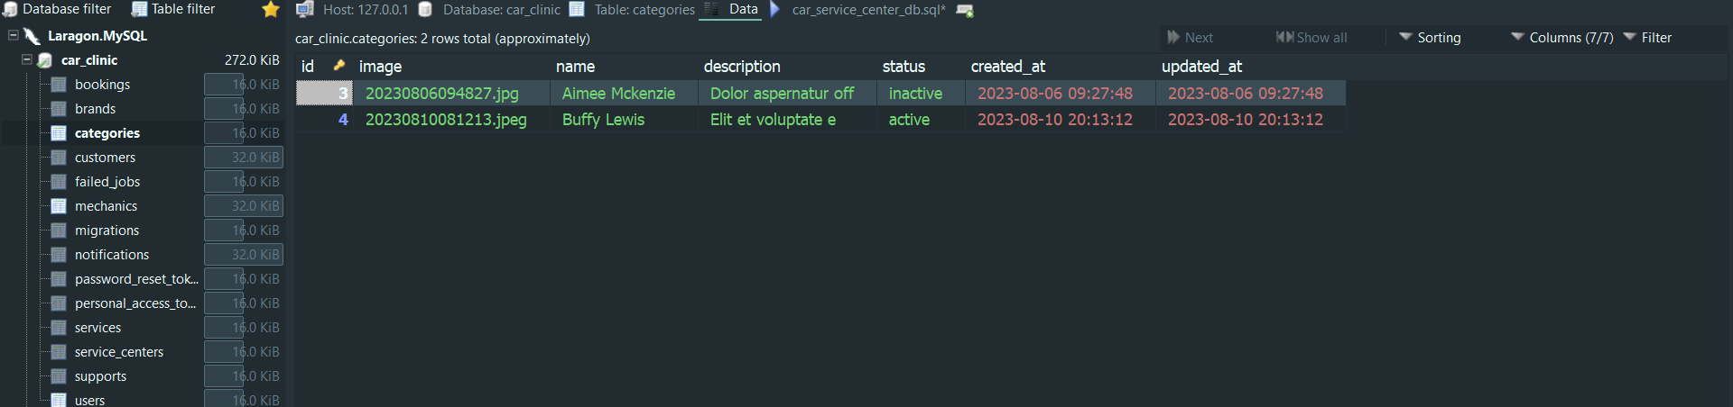

Figure 7.2: Category Table

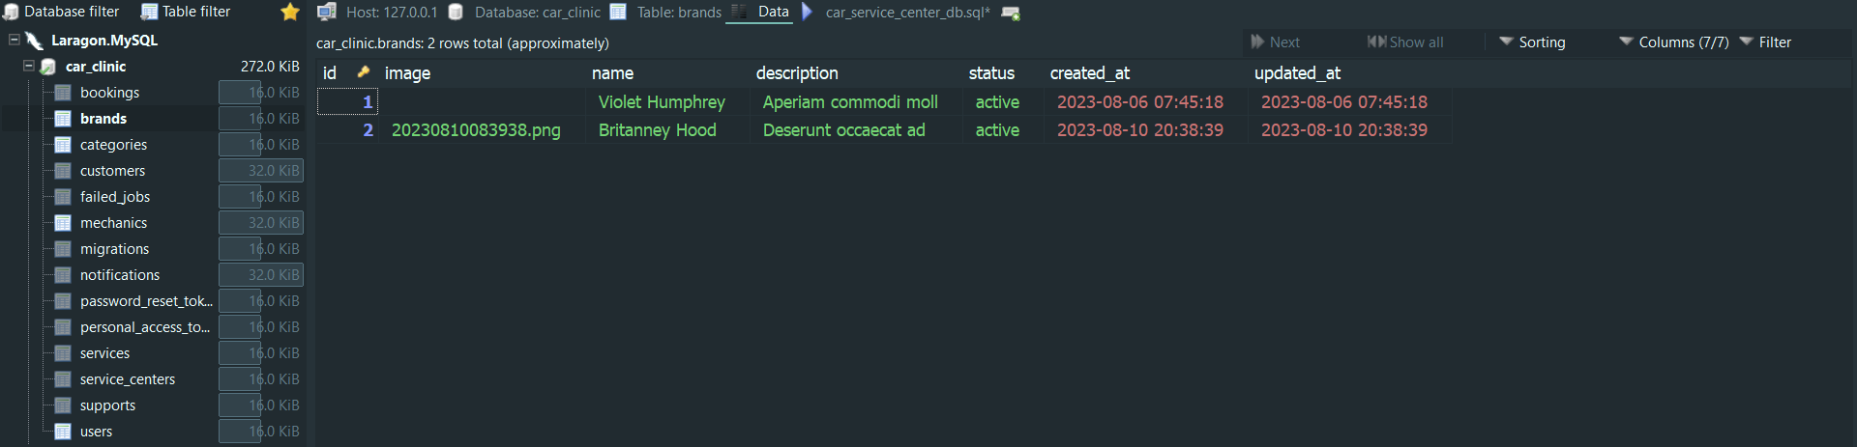

Figure 7.3: Brand Table

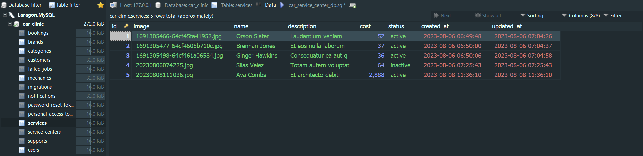

Figure 7.4: Service Table

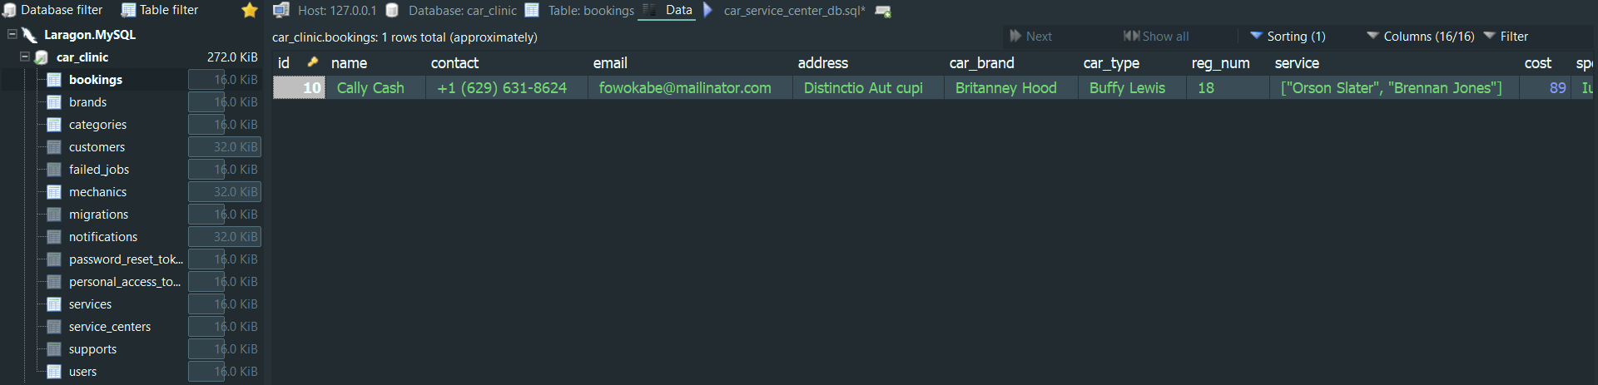

Figure 7.5: Booking Table

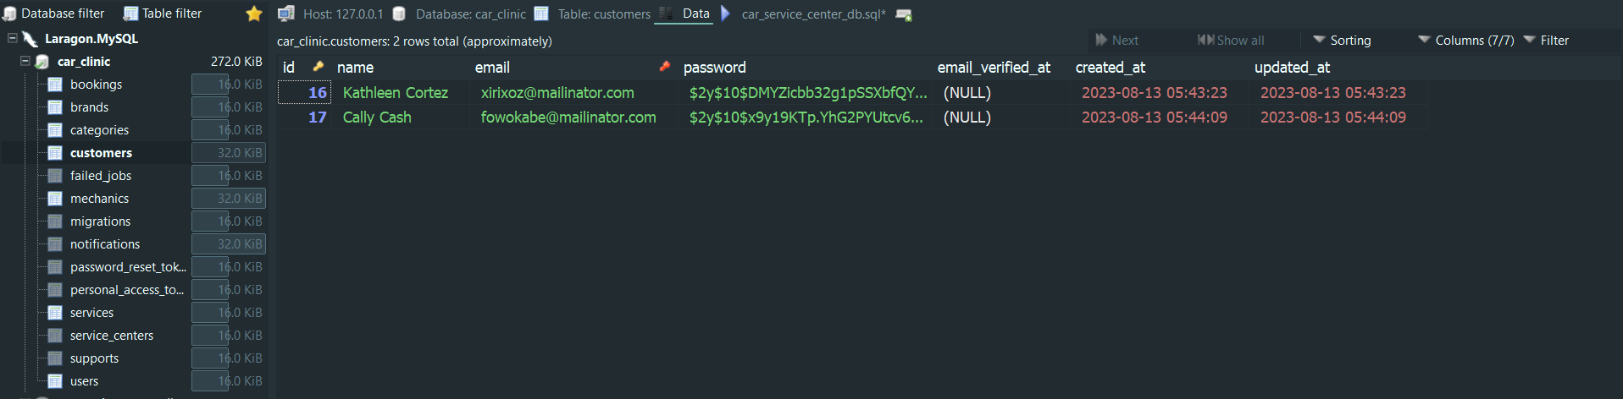

Figure 7.5: Customer Table

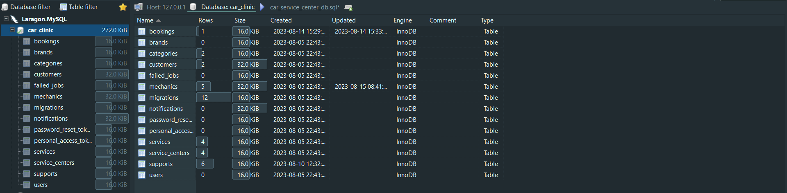

Figure 7.7: Full Database Table

**7.2 Interface Design** 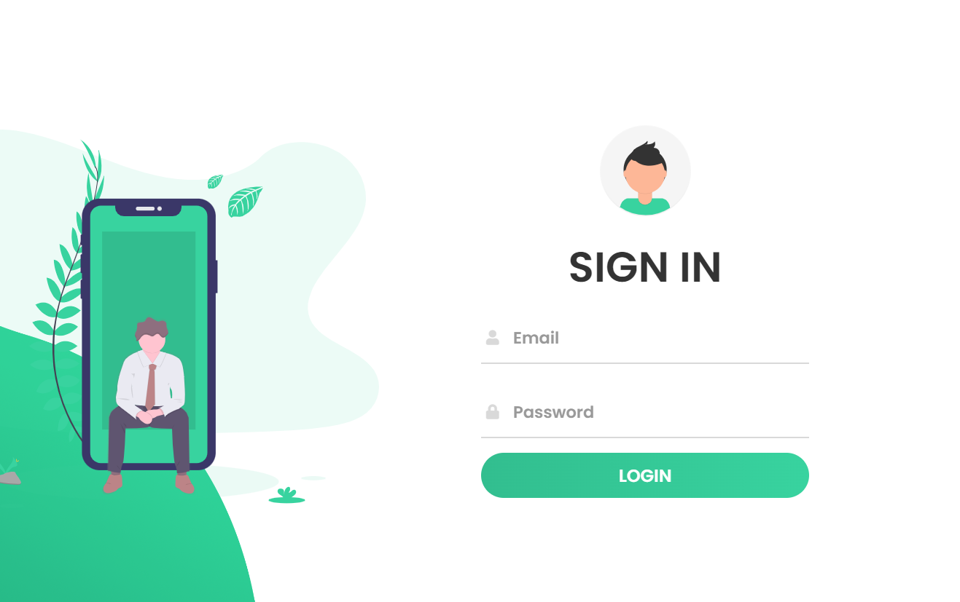

Figure 7.8: Admin Login Page

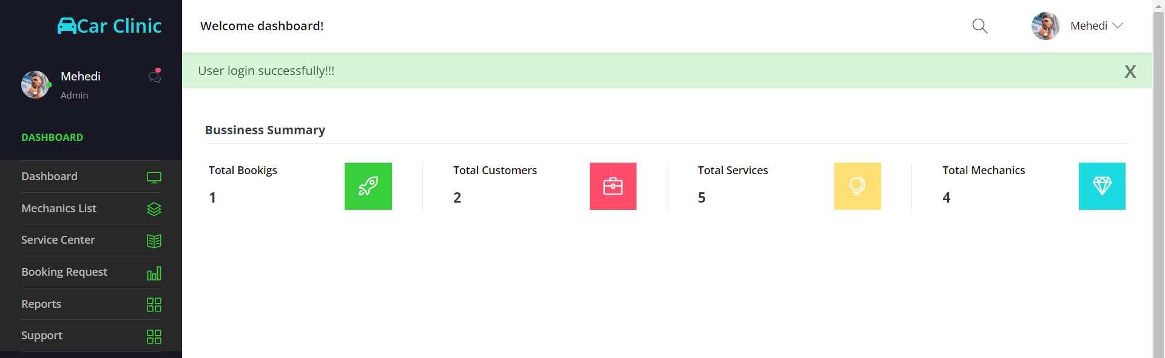

Figure 7.9: Dashboard Page

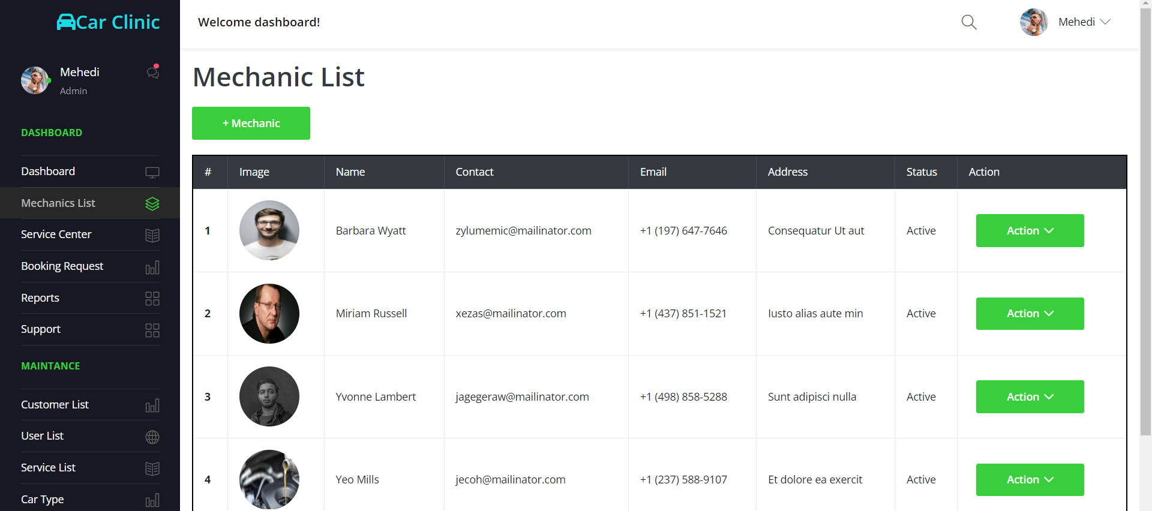

Figure 7.10: Add User Page

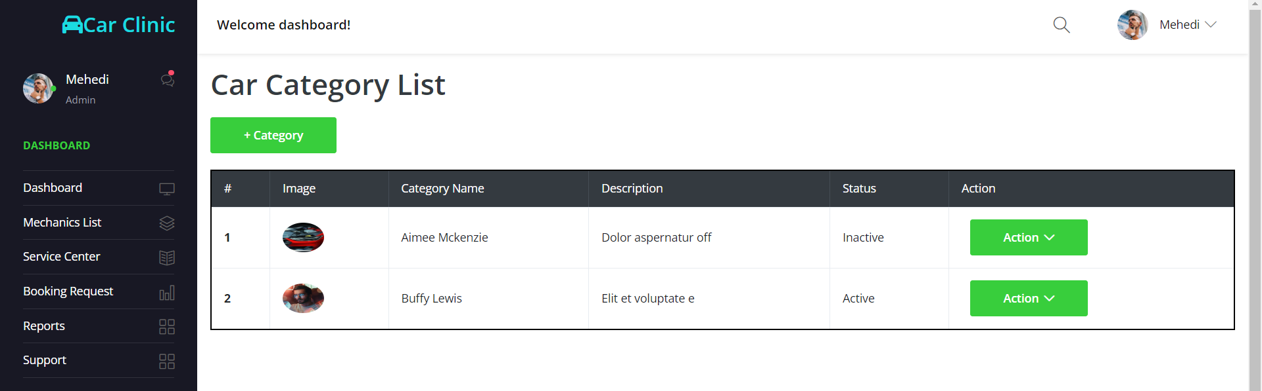

Figure 7.11: Manage Category Page

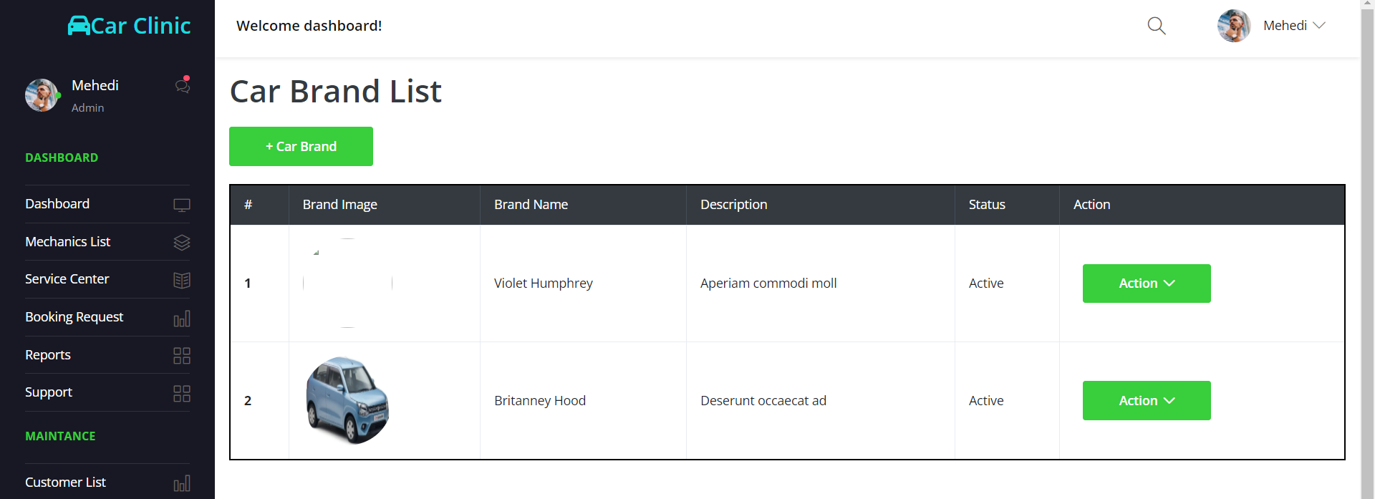

Figure 7.12: Add Brand Page

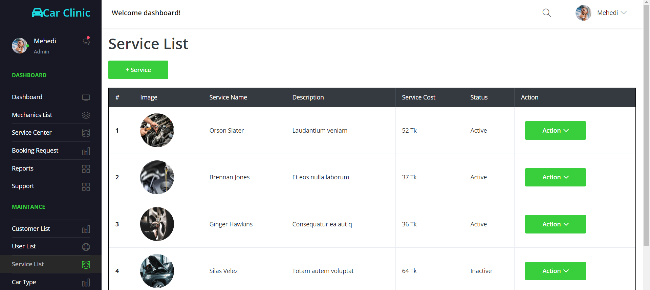

Figure 7.13: Manage Service Page

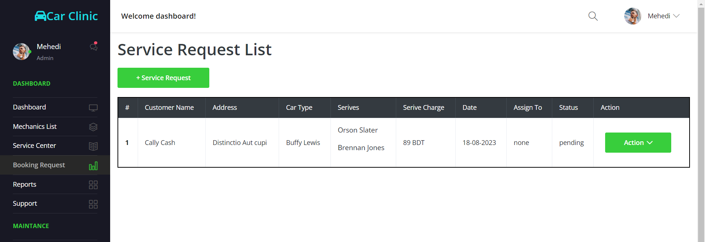

Figure 7.14: Booking Info Page

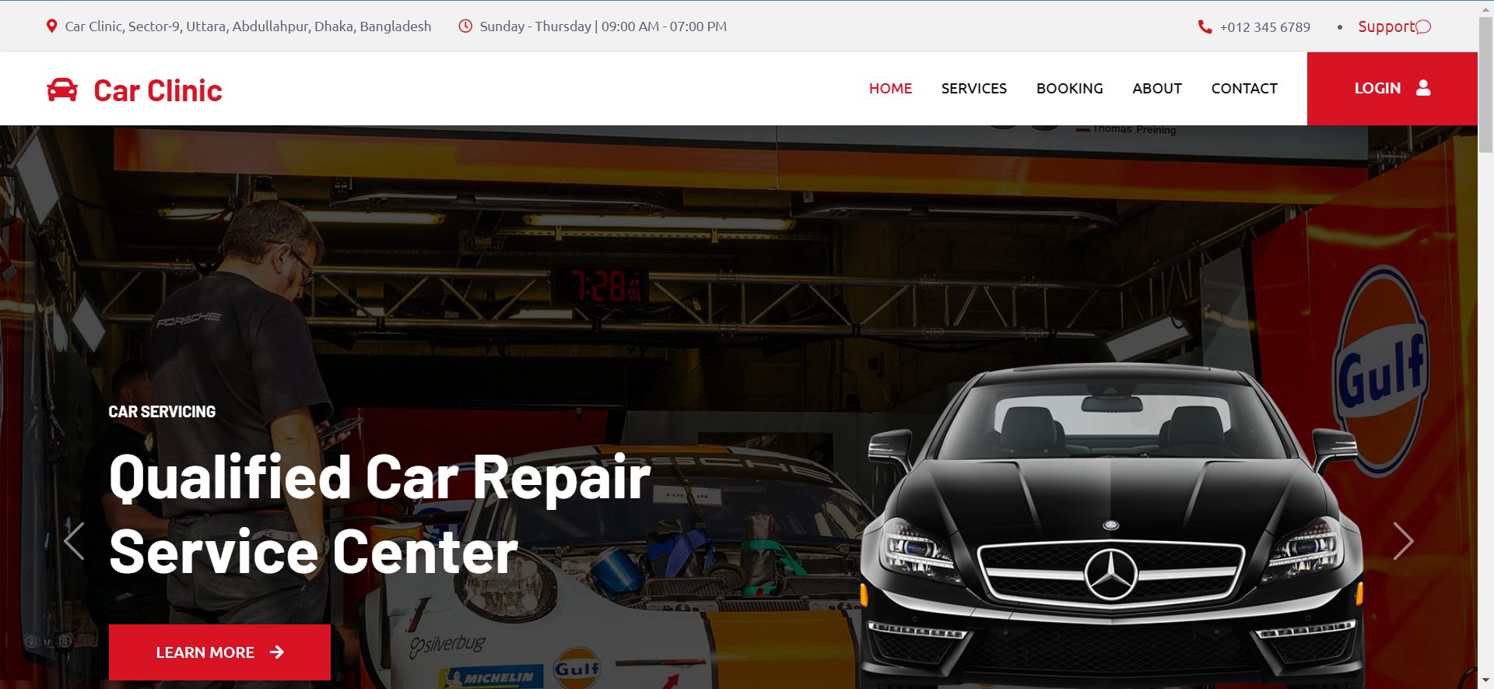

Figure 7.15: Home Page

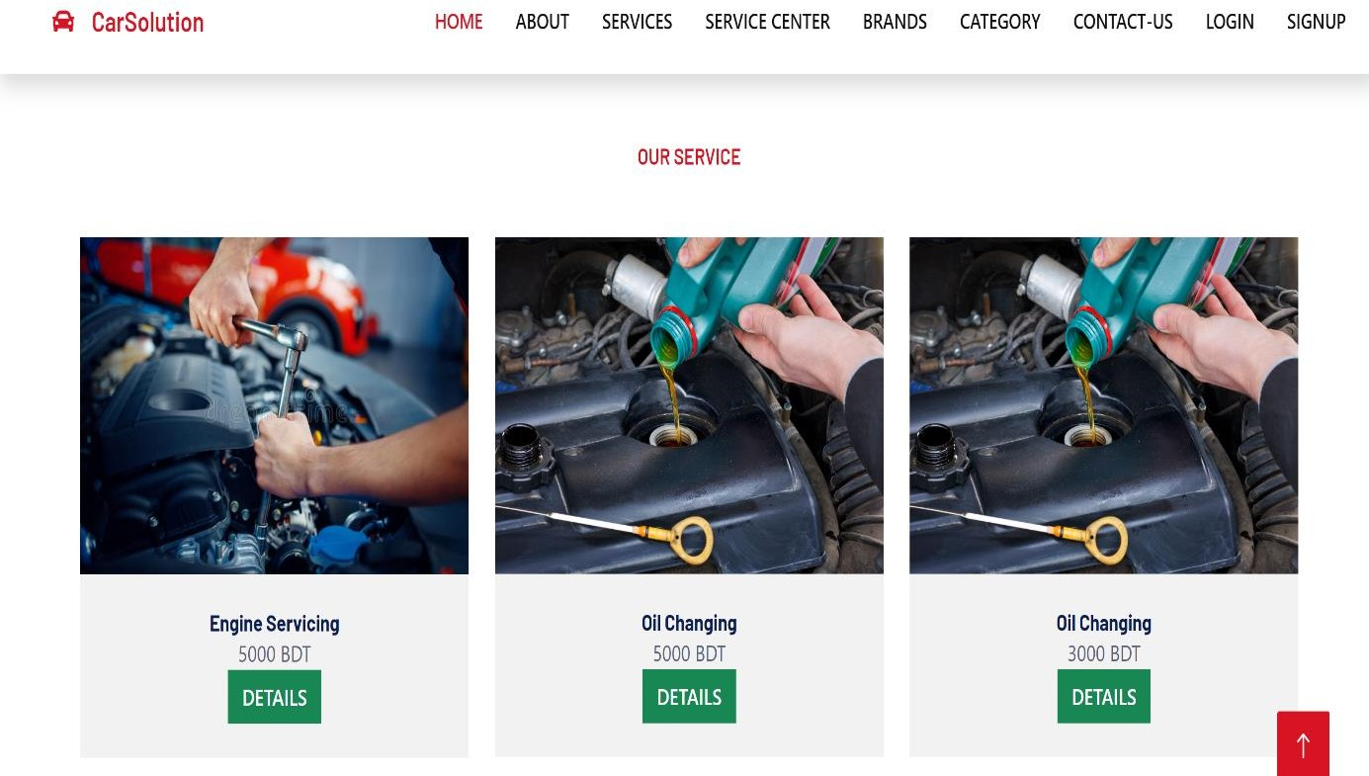

Figure 7.16: Service Page

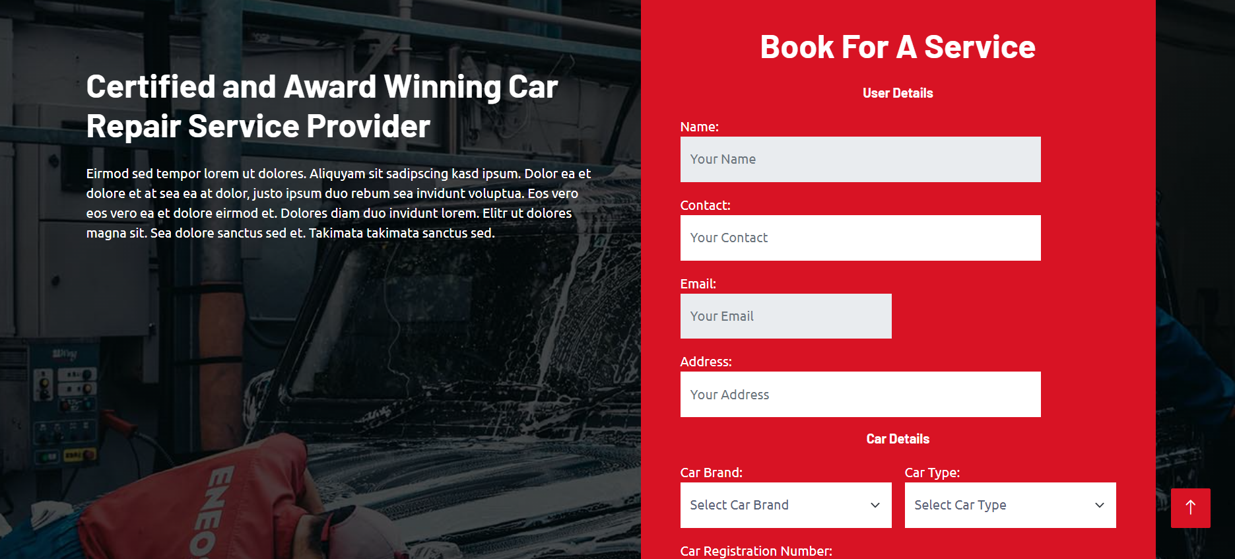

Figure 7.17: Booking Page

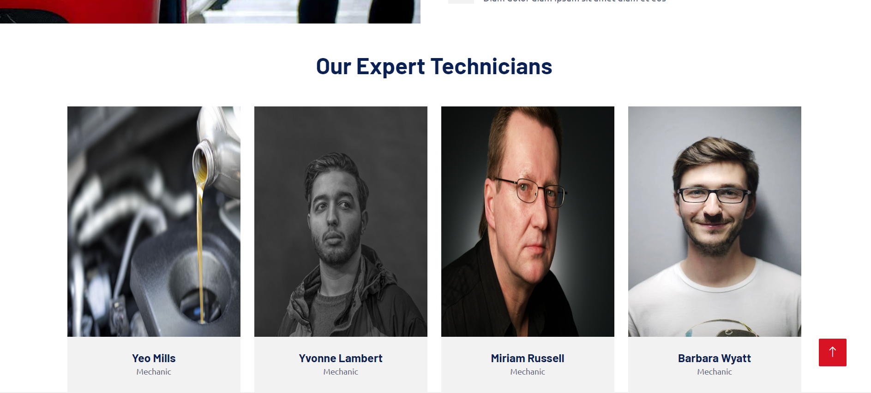

Figure 7.18: About Page

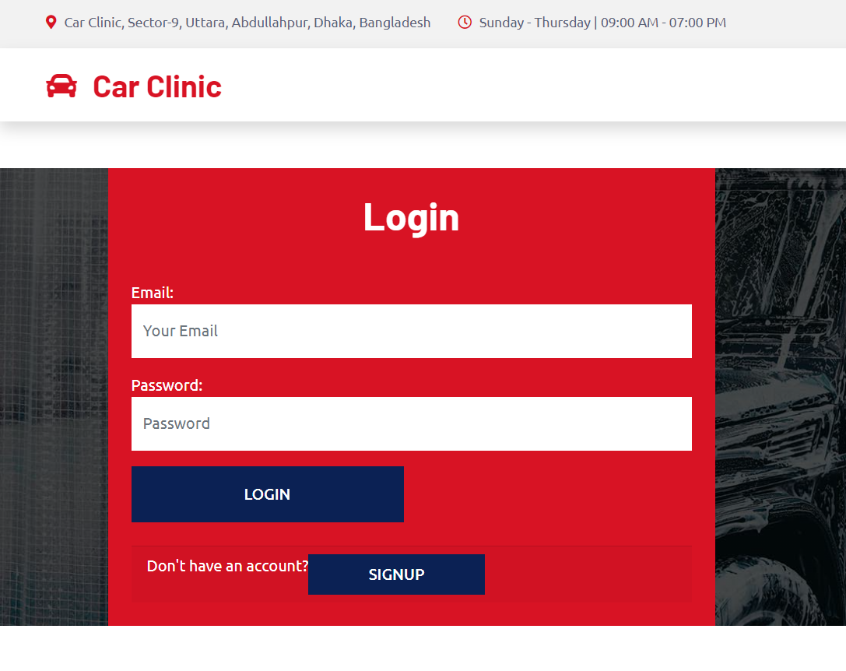

Figure 7.19: User Login Page

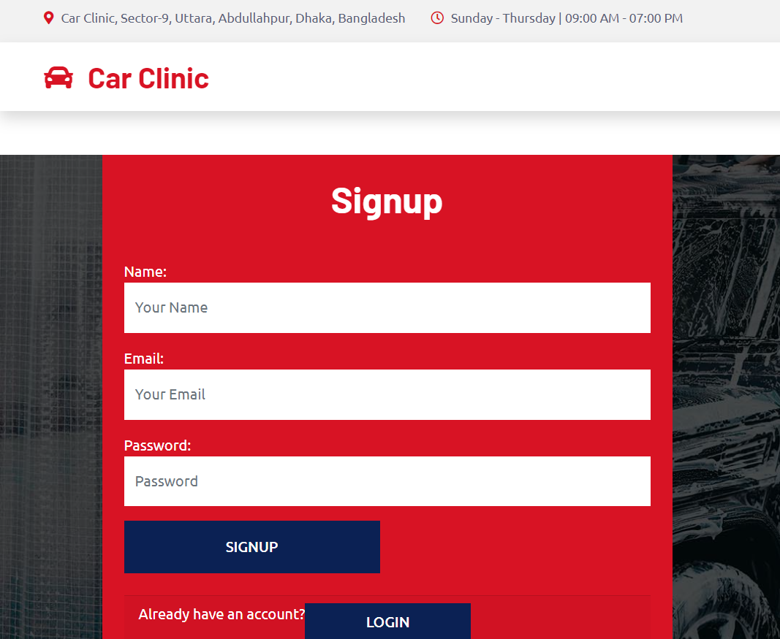

Figure 7.20: User Login Page

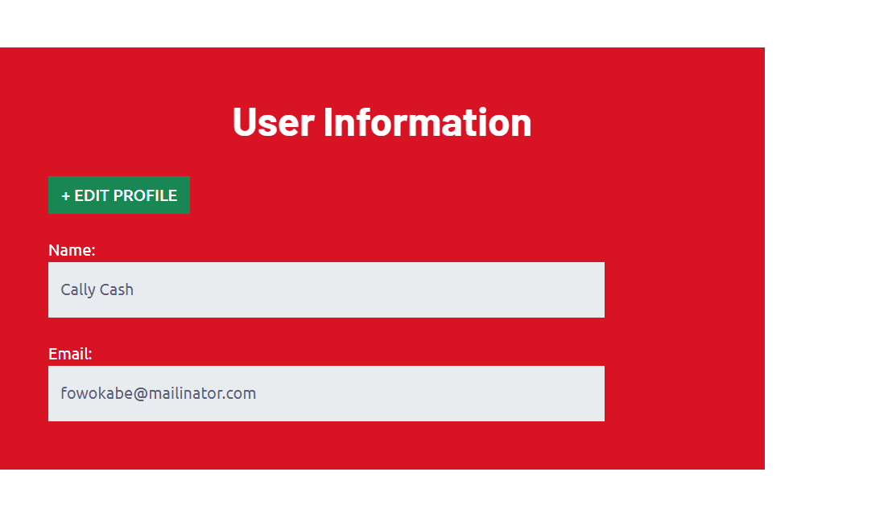

Figure 7.21: Customer Profile Page

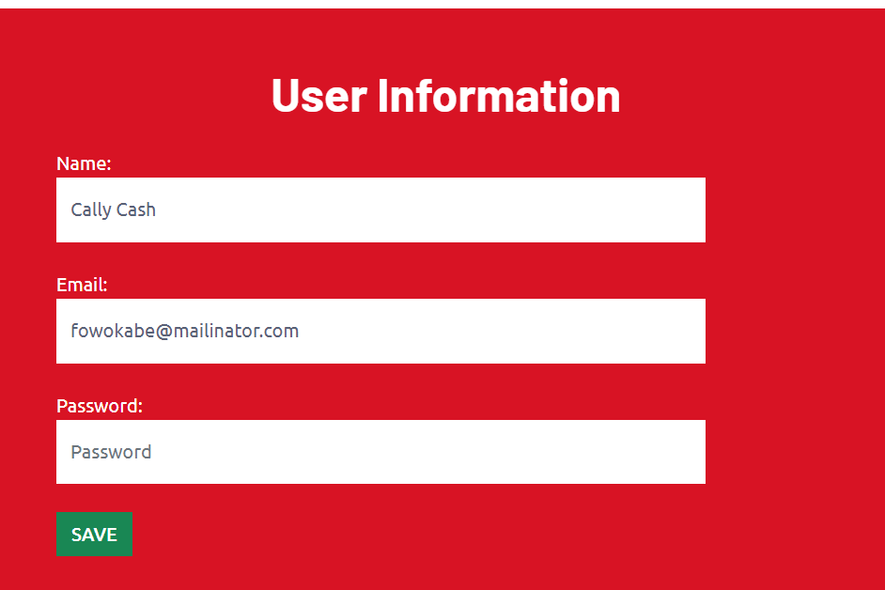

Figure 7.22: Customer Profile Edit Page

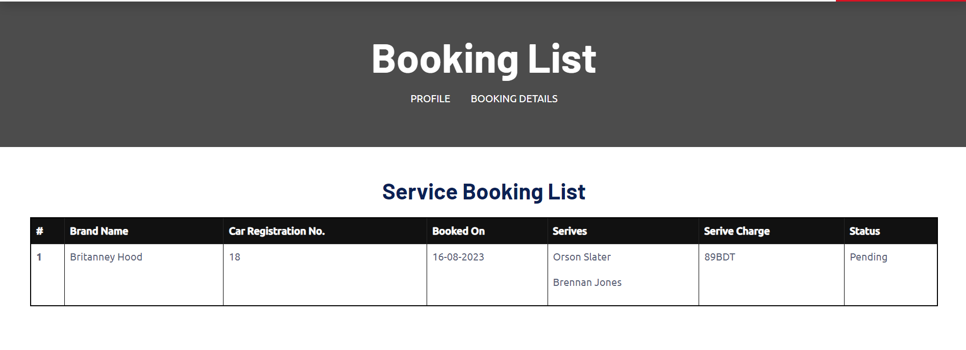

Figure 7.23: Customer Booking Info Page

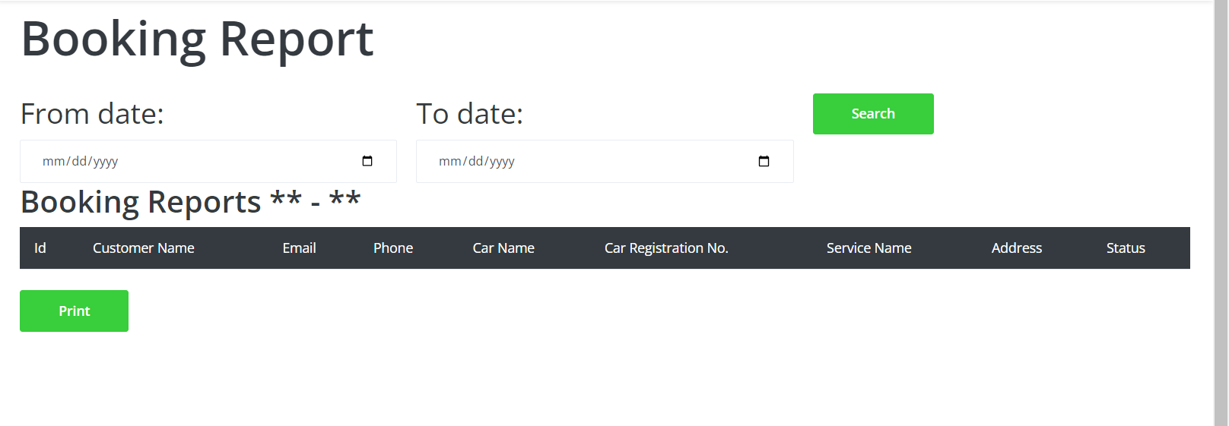

Figure 7.24: Service Report Page

**Chapter 08**

**Quality Assurance**

**8.1 System Testing**

Testing is the process of examining a system or its components to determine whether they meet requirements. Simply put, testing is the process of running a system to detect vulnerabilities, errors or missing requirements that the actual requirements can’t meet..

Knowing a specific feature the software is designed for allows you to run tests that fully demonstrate each feature while debugging each feature. This approach is called black box testing.

Internal operation software allows you to perform tests to ensure that internal operations are performing as intended and that all internal components are performing correctly. This method is known as white box testing.

**8.2 White Box Testing Results Table**

Test Title: User Registration Table

|  |  |  |  |  |
| --- | --- | --- | --- | --- |
| **Steps** | **Test Data** | **Expectation** | **Actual Result** | **Status** |
| Input New user Information | New user | New user will be Added | New User in User Table | PASS |
| Redirect to Admin Dashboard | Dashboard | Login page to Dashboard | Redirected to Dashboard after | PASS |

Test Title: Login Table

|  |  |  |  |  |
| --- | --- | --- | --- | --- |
| **Steps** | **Test Data** | **Expectation** | **Actual Result** | **Status** |
| Login with proper credentials | Email and Password | Respective Dashboard according to user- type | Redirected to respective dashboard according to user-type | PASS |

Test Title: Profile Management Table

|  |  |  |  |  |
| --- | --- | --- | --- | --- |
| **Steps** | **Test Data** | **Expectation** | **Actual Result** | **Status** |
| Profile Picture  Change | New Image from device | Showphoto | Photo Visible | PASS |
| Change General  Information | Name, Phone, Address | Show Updated Information in My Profile | Information  Updated | PASS |

Test Title: Added Contents Table

|  |  |  |  |  |
| --- | --- | --- | --- | --- |
| **Steps** | **Test Data** | **Expectation** | **Actual Result** | **Status** |
| Add brand | Brand | Brand will be added | Brand Added | PASS |
| Add Category | Category | Category Will be Added | Category Added | PASS |
| Add Service | Service | Service will be added | Service Added | PASS |

**Chapter 09**

**Conclusion**

**9.1 Conclusion**

This app developed for people so they can easily get any service. And they can easily find the service center nearby so they can easily get the service center website information. It reduces their time and also visualizes the service they have or not. This product helps to establish communication between administrators and employees. This project also helps to monitor any ongoing projects and their live updates. So help admins, mechanics and customers.

**9.2 Limitation**

* Users have limited access to functionality
* Customers are not allowed to add services
* The customer cannot manage the report
* The admin cannot manage the catalog

**9.3 Future Work**

* Login or Signup through google account or social media account.
* Send notification for customer booking.
* Email verification also available.
* A mobile app will be developed.
* Service center show on google map direction.

**References:**

Wang, X., Ning, Z. and Wang, L., 2018. Offloading in Internet of vehicles: A fog

enabled real-time traffic management system. *IEEE Transactions on Industrial Informatics*, *14*(10), pp.4568-4578.

Gandhi, B.K. and Rao, M.K., 2016. A prototype for IoT based car parking management system for smart cities. *Indian Journal of Science and Technology*, *9*(17), pp.1-6.

Namazi, E., Li, J. and Lu, C., 2019. Intelligent intersection management systems considering autonomous vehicles: A systematic literature review. *IEEE Access*, *7*, pp.91946-91965.

Djahel, S., Doolan, R., Muntean, G.M. and Murphy, J., 2014. A communications-oriented perspective on traffic management systems for smart cities: Challenges and innovative approaches. *IEEE Communications Surveys & Tutorials*, *17*(1), pp.125-151.

Li, S.G. and Kuo, X., 2008. The inventory management system for automobile spare parts in a central warehouse. *Expert Systems with Applications*, *34*(2), pp.1144-1153.

